TeraSort on Hadoop/Spark

Programming Assignment-2

Ahsan Burney

A20389603

Mohd Sadique

A20380442

*Introduction*

The goal of this programming assignment is to enable us to gain experience programming with:

* Amazon Web Services, specifically the EC2 cloud (<http://aws.amazon.com/ec2/>)
* The Hadoop framework (<http://hadoop.apache.org/>)
* The Spark framework (<http://spark.apache.org/>)

Four Different platforms are used to evaluate the performance of the TeraSort which is as follows:

* Java Shared Memory [Java 1.8]
* Hadoop [2.7.2]
* Apache Spark [1.6.0]

The performance of the application will be carried on the Amazon AWS in a Linux environment

*Setup*

***Hadoop***

The Apache™ Hadoop® project develops open-source software for reliable, scalable, distributed computing.

The Apache Hadoop software library is a framework that allows for the distributed processing of large data sets across clusters of computers using simple programming models. It is designed to scale up from single servers to thousands of machines, each offering local computation and storage. Rather than rely on hardware to deliver high-availability, the library itself is designed to detect and handle failures at the application layer, so delivering a highly-available service on top of a cluster of computers, each of which may be prone to failures.

The project includes these modules:

* Hadoop Common: The common utilities that support the other Hadoop modules.
* Hadoop Distributed File System (HDFS™): A distributed file system that provides high-throughput access to application data.
* Hadoop YARN: A framework for job scheduling and cluster resource management.
* Hadoop MapReduce: A YARN-based system for parallel processing of large data sets.

We can operate Hadoop cluster in one of the three supported modes:

* **Local/Standalone Mode**: After downloading Hadoop in your system, by default, it is configured in a standalone mode and can be run as a single java process.
* **Pseudo Distributed Mode**: It is a distributed simulation on single machine. Each Hadoop daemon such as hdfs, yarn, MapReduce etc., will run as a separate java process. This mode is useful for development.
* **Fully Distributed Mode**: This mode is fully distributed with minimum two or more machines as a cluster. We will come across this mode in detail in the coming chapters.

The following are the list of files that you have to edit to configure Hadoop.

**core-site.xml:**

This XML configuration file lets you setup site specific properties, such as I/O settings that are common to HDFS and MapReduce.

<property>

<name>hadoop.tmp.dir</name>

<value>/mnt/raid/temporary_dir</value>

</property>

**hdfs-site.xml:**

We will tell hadoop where is the name node directory (which we created previously at the end of Hadoop installation) and how many backup copies of the data files to be created in the system (called replication) inside this file under the configuration tag.

<configuration>

<property>

<name>dfs.replication</name>

<value>1</value>

</property>

<property>

<name>dfs.namenode.name.dir</name>

<value>file:///mnt/raid/temporary_dir/namenode</value>

</property>

<property>

<name>dfs.datanode.data.dir</name>

<value>file:///mnt/raid/temporary_dir/datanode</value>

</property>

</configuration>

**mapred-site.xml:**

This controls the configuration settings for MapReduce daemons. Here we need to ensure that we will be using YARN framework. Also we will configure the MapReduce Job History server.

**masters:**

The IP address of the master node is on this file. Public IP of the master is this.

<property>

<name>mapreduce.map.memory.mb</name>

<value>2560</value>

</property>

<property>

<name>mapreduce.reduce.memory.mb</name>

<value>5120</value>

</property>

**Slaves:**

The IP addresses of the slave in the cluster are on this file. Also master IP can be assigned here, that can indicate that the master node is also running a slave process in it.

*Single Node Setup:*

**Creating an account**

To create accounts go to the following URL: http://aws.amazon.com/ec2/ and click on “Sign in to Console”. Once there, you have the option to log in or to create a new one.

We need to set up a credit card. But we will not be charged for the services because Amazon free services and the coupon should be enough.

**The console**

**i3.large Instance**

Click on login and provide the userId and password. When logged in select Amazon EC2 from the “Services” menu at the top.

From the provided list of AMIs select Amazon Linux AMI.



Select instance *“i3.large”* from the given list of instances.

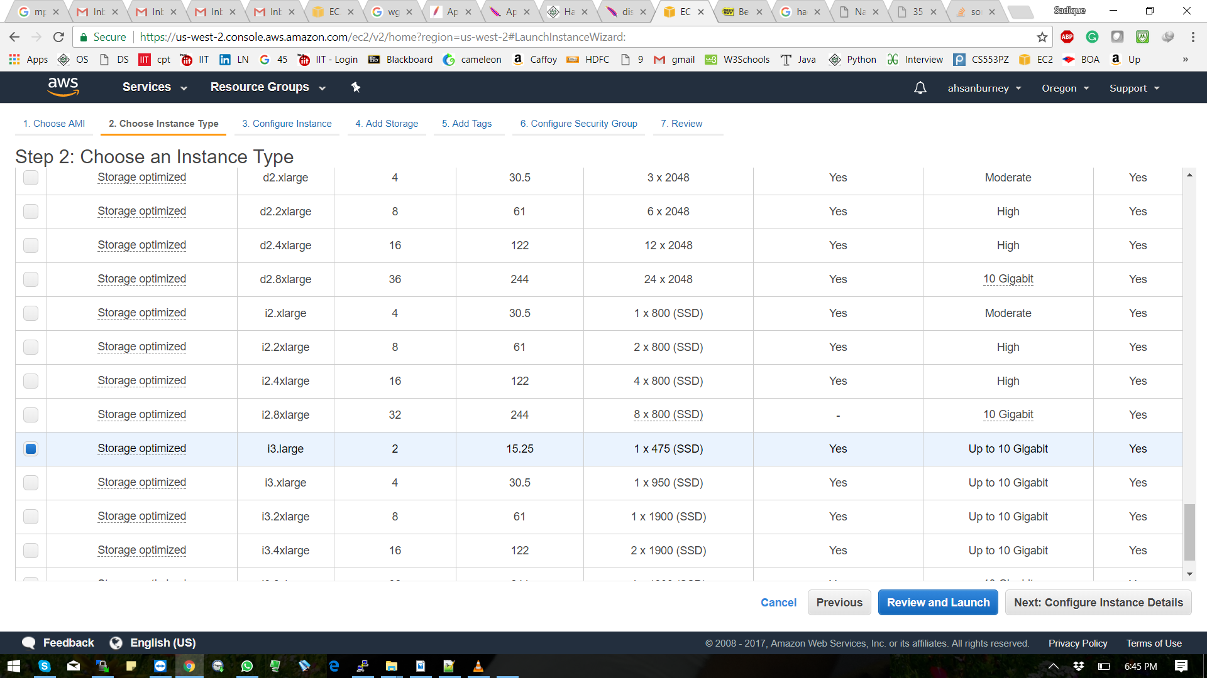

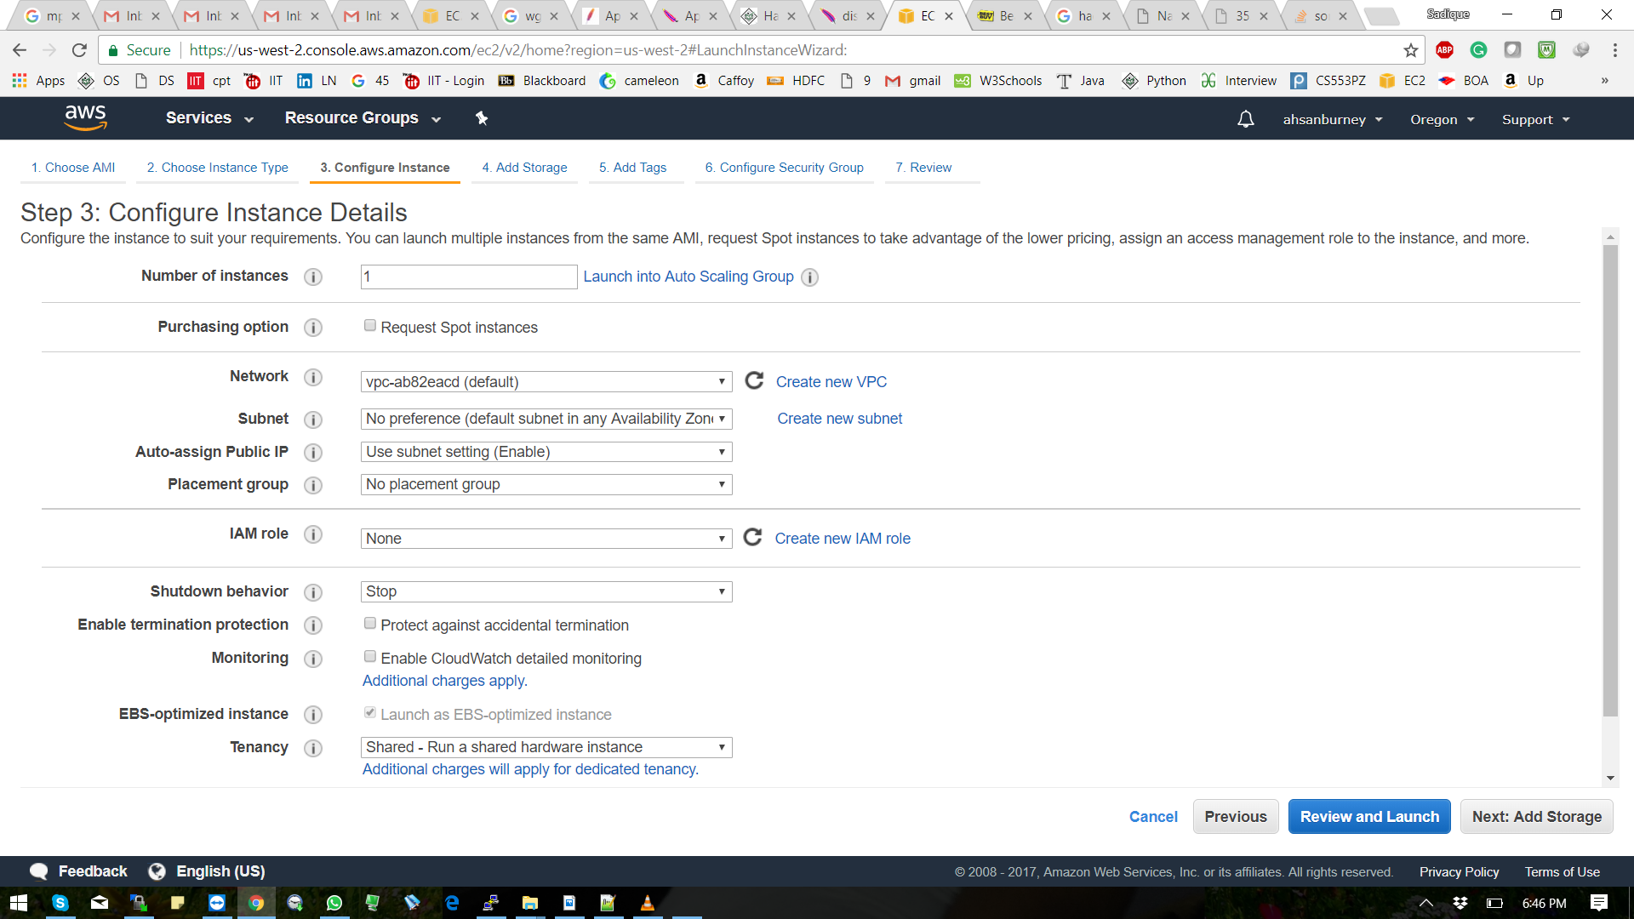

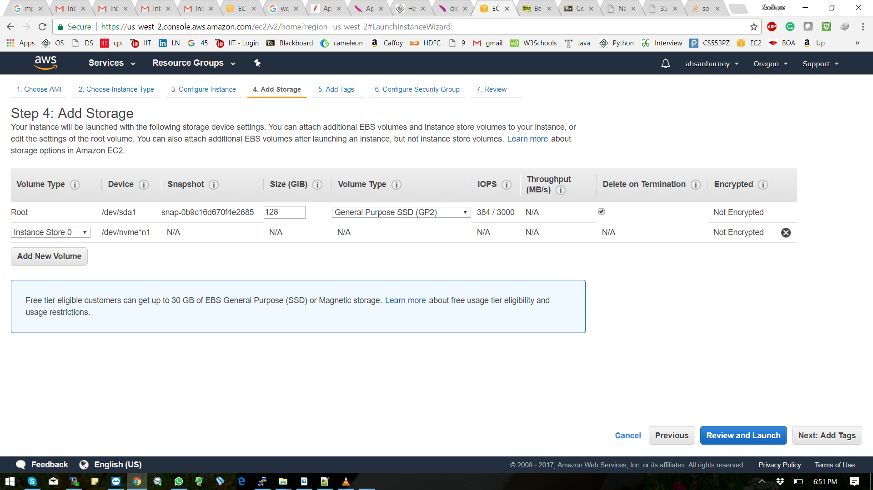

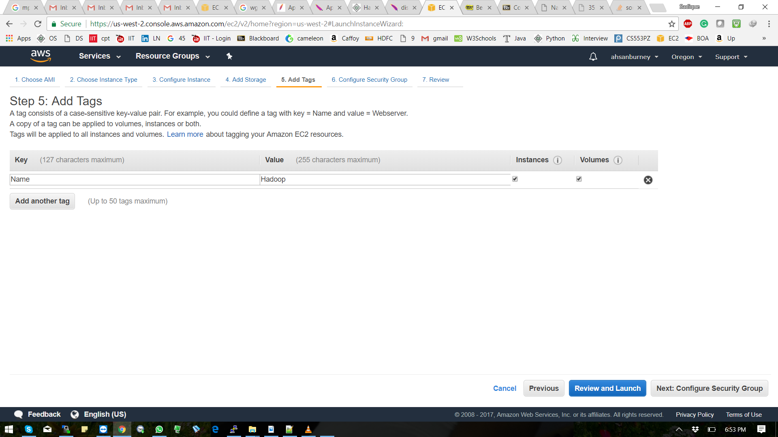

Now in the configure security group, select the security group that has

been created to allow SSH and TCP connections from the user and other

instances.

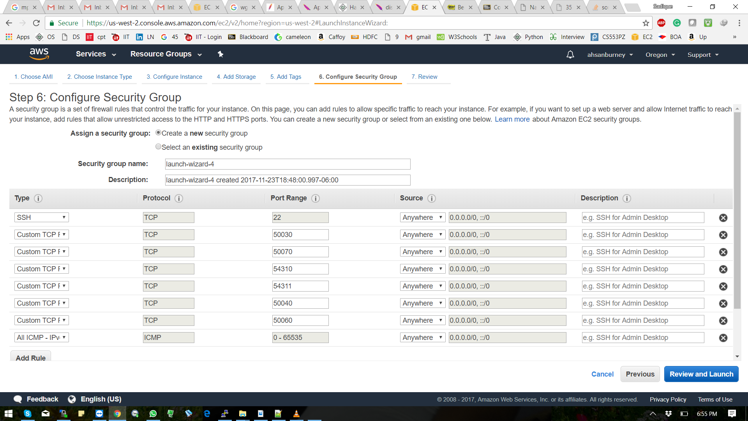

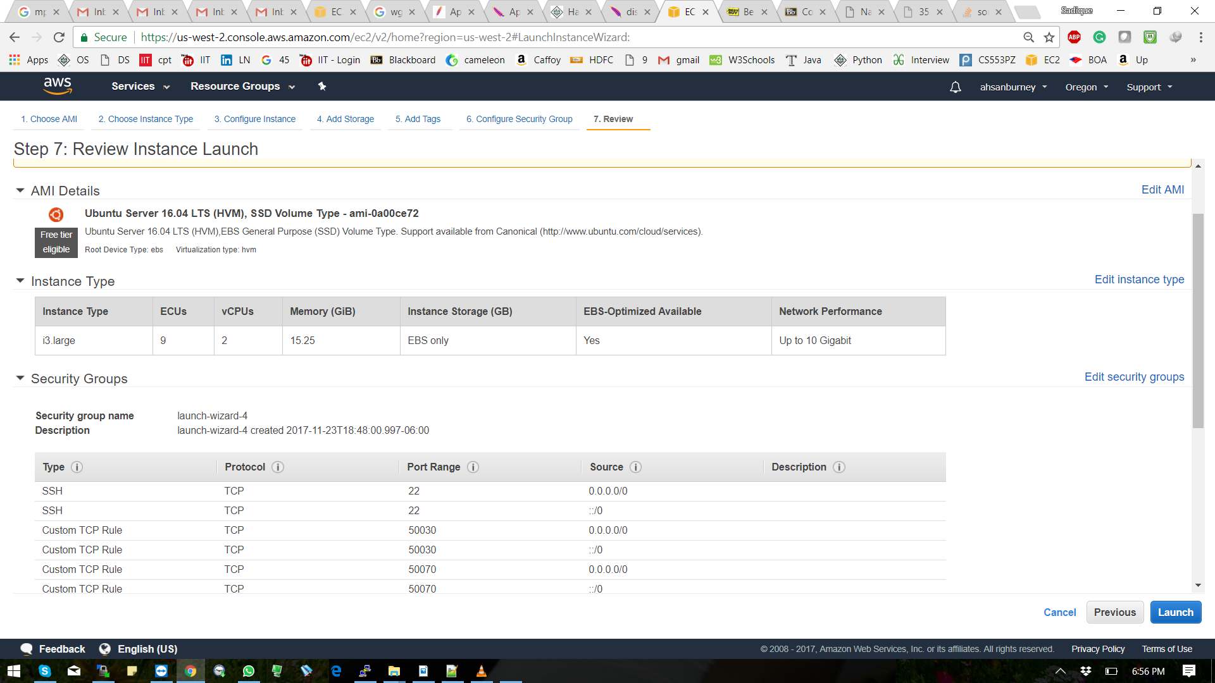

Select an existing key pair or create a new key pair for connecting to instance from local and select “Launch Instance”.



Below screenshot shows that instance is up and running

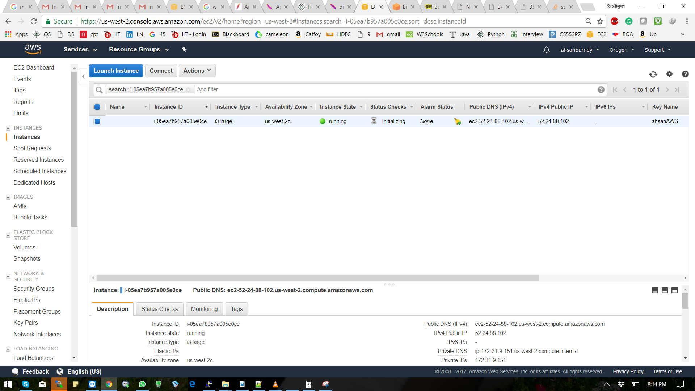

Installing Java

First we need to go to the following site: http://www.oracle.com/technetwork/java/javase/downloads/jdk8-downloads-2133151.html and download the version 8 of JDK, and then copy it (using scp) to your AMI instance. You can also take advantage of the fast Internet interconnection available to Amazon and download the software directly to you AMI. For that, execute the following command:

$ wget nocheckcertificate --nocookies --header “Cookie: oraclelicense=acceptsecurebackupcookie” <http://download.oracle.com/otnpub/> java/jdk/8u45b14/jdk8u45linuxx64.tar.gz

Now, untar the compressed file:

$ tar xvzf -jdk8u45linuxx64.tar.gz

Create a symbolic link that will make your life easier when setting your configuration

$ ln -s jdk1.8.0_45 jdk

Now you need to edit yor .bashrc file and add two lines:

export PATH=~/jdk/bin:$PATH

export JAVA_HOME=~/jdk

If you exit from your session and ssh to your AMI again, you should see this when doing java -version:

ubuntu@ip10831845:~$ java –version

java version "1.8.0_45"

Java(TM) SE Runtime Environment (build 1.8.0_45b14)

Java HotSpot(TM) 64-Bit Server VM (build 25.45b02, mixed mode)

ubuntu@ip10831845:~$

Installing Hadoop

Now, we are going to install hadoop and run it:

Download hadoop:

$ wget http://download.nextag.com/apache/hadoop/common/hadoop2.7.0/hadoop2.7.0.tar.gz

Untar the compressed file:

$ tar xvzf hadoop2.7.0.tar.gz

Create a symbolic link that will make your life easier when setting your configuration

$ ln -s hadoop2.7.0 hadoop

Now you need to edit yor .bashrc file:

export PATH=~/hadoop/bin:~/hadoop/sbin:~/jdk/bin:$PATH

export JAVA_HOME=~/jdk

export HADOOP_HOME=~/hadoop

* All the installation steps for executing Hadoop is written in the script “hadoop_install.sh”
* First run the above script.
* Now generate the public/private RSA keys. Execute the following command:

$ ssh-keygen

* The key will be generated and stored. Now copy the generated key to the “authorized_keys”

.$ vim .ssh/authorized_keys

* Now create a config file in the folder "~/.ssh/" and add the following line

StrictHostKeyCheck=no

And change the permissions to 600 using chmod.

* Now ssh the master itself for Checking if the ssh works.

$ ssh localhost

* First set the master and slaves. Create the files “masters” and “slaves” in the directory. Add the private IP of the master node in the masters and slaves file.

hadoop/etc/hadoop/masters

hadoop/etc/hadoop/slaves

* Create a temporary directory for the Hadoop

$ mkdir /mnt/raid/tmp

* Chage code in the core-site.xml file.

$ vim hadoop/etc/hadoop/coresite.xml

Following properties should be added into it.

<property>

<name>hadoop.tmp.dir</name>

<value>/mnt/raid/tmp</value>

</property>

<property>

<name>fs.defaultFS</name>

<value>hdfs://private_ip:9000</value>

</property>

* Then modify the hdfs-site.xml to set the level of replication. As dataset is large. We will set the replication level to 1

<property>

<name>dfs.replication</name>

<value>1</value>

</property>

* Modify mapred-site.xml with the below property

<property>

<name>mapreduce.framework.name</name>

<value>yarn</value>

</property>

* Add below property in the yarn-site.xml

<property>

<name>yarn.resourcemanager.hostname</name>

<value>private_ip</value>

</property>

* Format Namenode before executing the Hadoop.

$ hdfs namenode –format

* To start the HDFS and the yarn execute the following command:

$ start-dfs.sh

$ start-yarn.sh

* To Check if all the processess are working:

$ jps

1604 NameNode

1975 SecondaryNameNode

2361 Jps

2330 NodeManager

2174 ResourceManager

1758 DataNode

* Copy the input data file to HDFS:

$ hdfs dfs -copyFromLocal <input_file_location> /input

* To check if the file has been copied properly.

$ hdfs dfs –ls /

* Run the application:

$ hadoop jar hterasort.jar <input_file_name> /output

* Copy the output data file from HDFS to local:

$ hdfs dfs -copyToLocal /ouput <ouput_file_location>

*Multi Node Cluster Setup:*

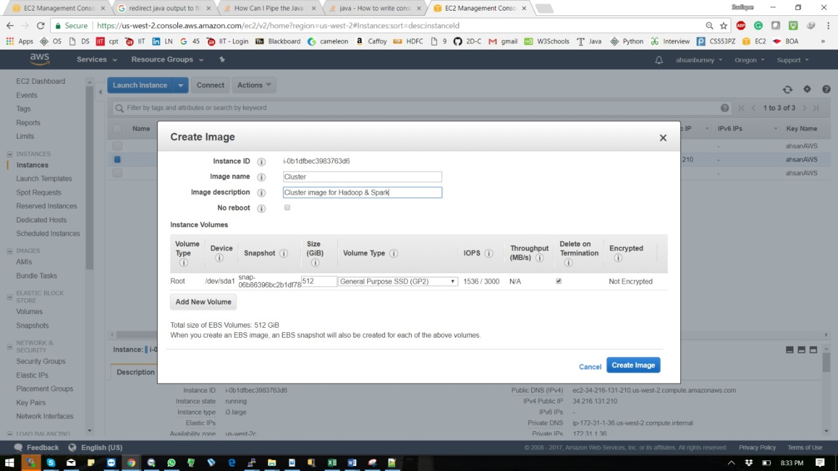

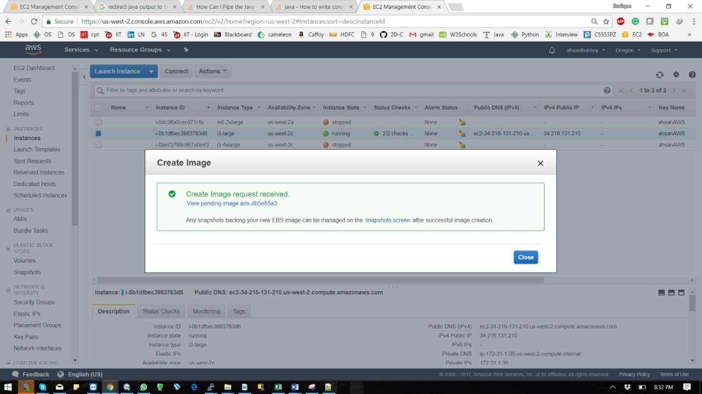

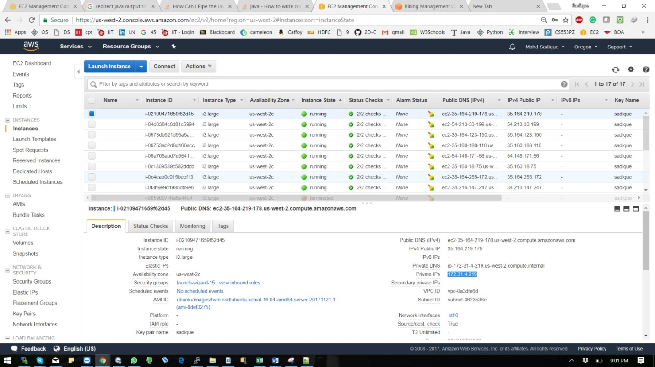

*Installation steps:*

The multi node setup for Hadoop was done in Fully-Distributed mode. This setup is similar to the single node setup.

***Shared Memory Set up***

* First go to you amazon AWS dashboard and launch instances like we did in hadoop.
* Instances that we need to launch are i3.large and i3.4xlarge
* Download Gensort from:

<http://www.ordinal.com/try.cgi/gensort-linux-1.5.tar.gz>

* Commands to extract the downloaded zip file: $ tar -xvzf hadoop-2.7.2.tar.gz
* Inside extracted folder 64, type command to generate dataset: $ ./gensort -a <file_size> <file_name>
* Copy your program script in to the root of the instance using your favorite tool like winscp or filezilla.
* Install java jdk and run file make using command:

Sudo apt install default-jdk

Sudo apt install make

* The application will give the following options:

a. Input file name

b. Output file name:

c. Number of threads:

* Execute make
* Record the output for reporting.

Mkdir output

Generate input.txt using gensort file and store the input.txt in the same location of the java file.

./gensort -a <filesize> <filelocation>

Example for 128 GB : ./gensort -a 1374389534 input.txt

The input and output filename is hard cored in the code so make sure the input file name is input.txt when generating the file with the desired size using gensort.

Run make or compile the java file as javac filename.java and run by java filename

Note the output for reporting.

***SPARK***

Apache Spark is a fast, in-memory data processing engine with elegant and expressive development APIs to allow data workers to efficiently execute streaming, machine learning or SQL workloads that require fast iterative access to datasets. With Spark running on Apache Hadoop YARN, developers everywhere can now create applications to exploit Spark’s power, derive insights, and enrich their data science workloads within a single, shared dataset in Hadoop.

The Hadoop YARN-based architecture provides the foundation that enables Spark and other applications to share a common cluster and dataset while ensuring consistent levels of service and response. Spark is now one of many data access engines that work with YARN in HDP.

Single Node Spark implementation

Instances set-up for single node Spark implementation.

Standalone

1. The spark set up is very similar to the Hadoop as it uses the hadoop HDFS system for

files.

2. First go through the instructions provided for hadoop set up and install all the files.

3. Configure the Hadoop as given in the instructions.

4. Modify the *“spark-env.sh”* file located in the directory “spark/conf/”. Add the

following properties to it.

export SPARK_WORKER_DIR=/mnt/raid/tmp

export SPARK_WORKER_MEMORY=2g

export SPARK_WORKER_INSTANCES=1

export SPARK_MASTER_IP=<IP_of_master_node>

5. Start the master and slaves using the following command from directory

“*spark/sbin/”*

$ ./start-master.sh

$ ./start-slave.sh

Experimental Results

Hadoop

Test 1:

Environment

Instance d2.xlarge

Number of nodes 1

Mode Pseudo-distributed

Master nodes 1

Slave nodes 1

Application TeraSort

Language Java

Test file size 1GB

Results

Time taken for running job = 145 secs

File size = 1GB

Throughput =

!∗!#$%

!%& = 7.06 MB per sec

Screenshots

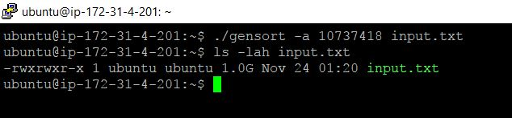

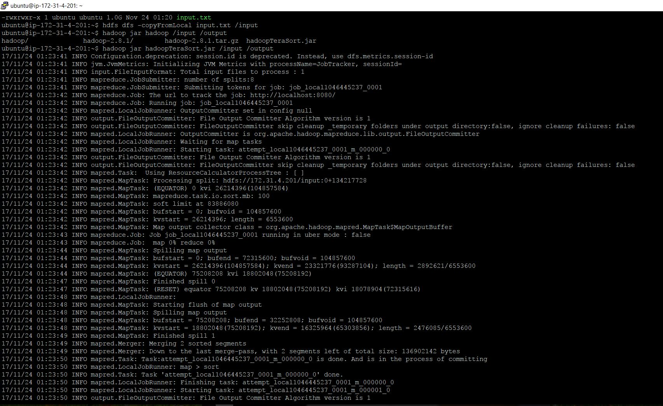

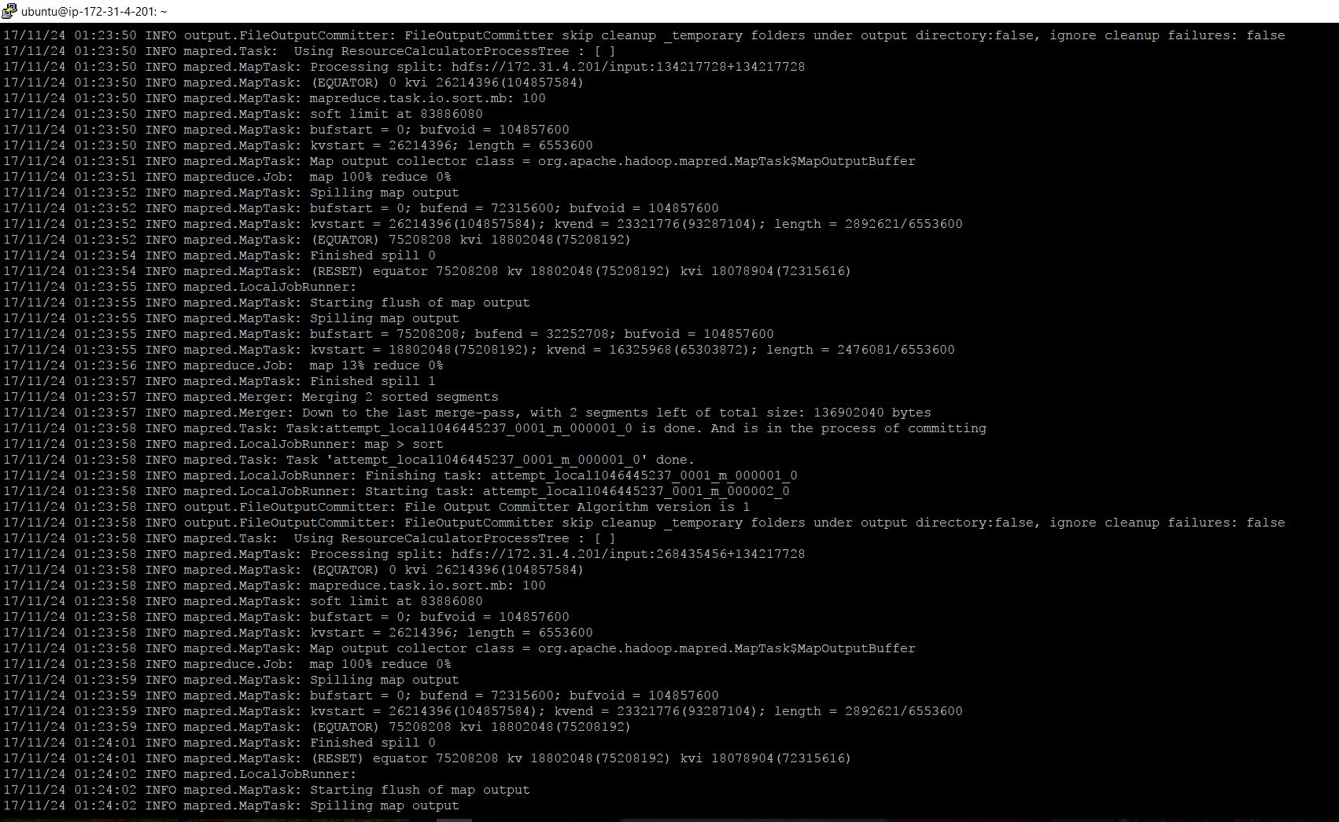

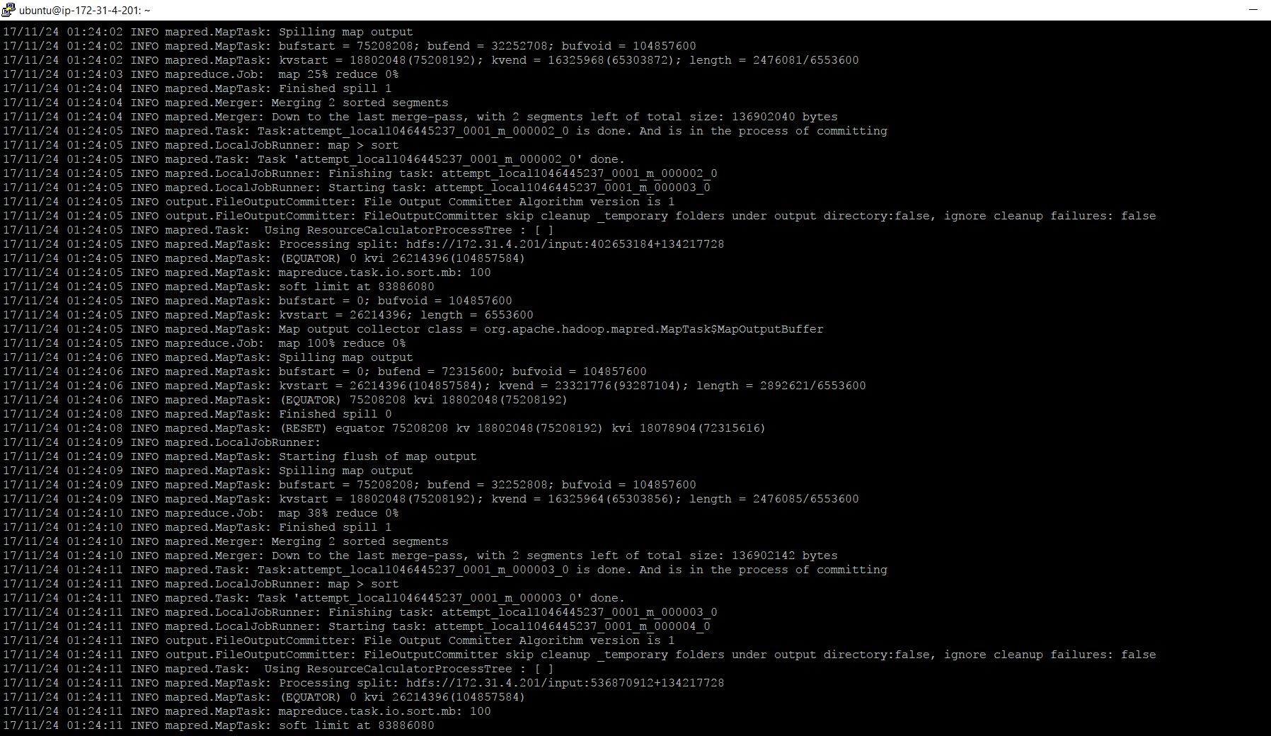

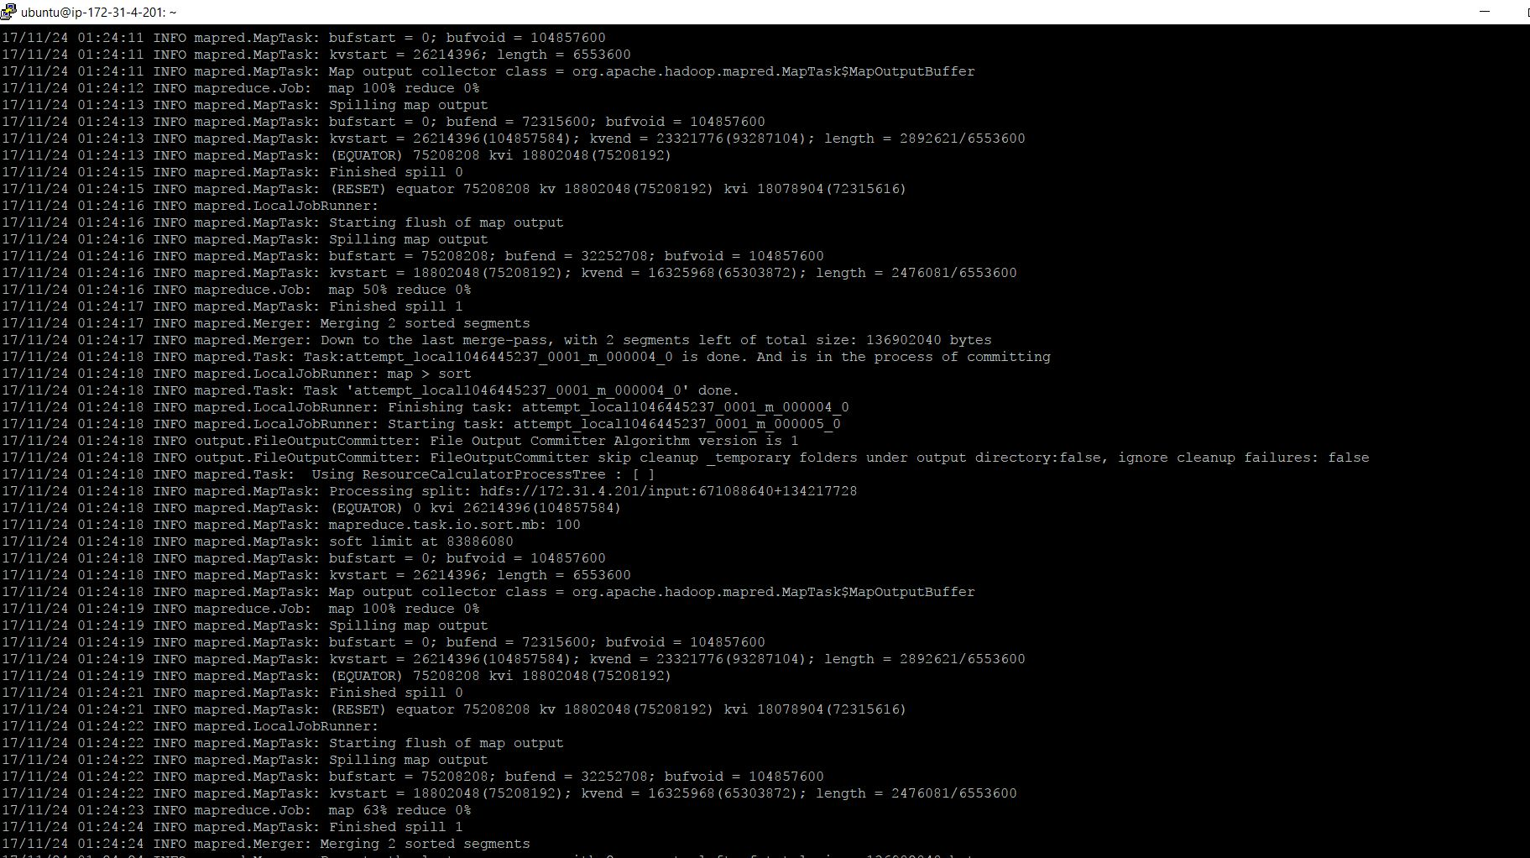

Multi Node(Cluster)

The multi node setup for Hadoop was done in Fully-Distributed mode. The setup for themultimode cluster is very similar to the single node setup. The setup of the Fully-Distributed

Mode is explained below.

Environment

Instance c3.large

Number of nodes 17

Master nodes 1

Slave nodes 16

Master Storage 435GB

Slave Storage 100GB

Application TeraSort

Language Java

Test file size 100GB

Steps

In the setup of cluster, the steps are similar to the single node setup. So we will create image

of the master that was created in the Single Node setup. And launch 16 instances of cluster

from the image of master.

Common configurations

1. Since we have launched the slaves from the image of the master all the

configuration files will be same in the slaves and master.

2. The following files will remain same for both master and slaves.

• core-site.xml

• hdfs-site.xml

3. In the mapred-site.xml add the following property and transfer it to all slaves using

the PSCP (As explained in the beginning).

<property>

<name>mapred.jobtracker.address</name>

<value>private_ip_of_master:54311</value>

</property>

4. In the yarn-site.xml we will be adding properties that will enable the web UI for

tracking the jobs and nodes in the cluster. Add the following property to yarnsite.

xml and send it to the slaves using PSCP

<property>

<name>yarn.resourcemanager.hostname</name>

<value> private_ip_of_master </value>

</property>

<property>

<name>yarn.nodemanager.aux-services</name>

<value>mapreduce_shuffle</value>

</property>

<property>

<name>yarn.nodemanager.auxservices.mapreduce_shuffle.clas

s</name>

<value>org.apache.hadoop.mapred.ShuffleHandler</value>

</property>

<property>

<description>The address of the scheduler interface.

</description>

<name>yarn.resourcemanager.scheduler.address</name>

<value>${yarn.resourcemanager.hostname}:8030</value>

</property>

<property>

<description>The address of the applications manager

interface in the RM.</description>

<name>yarn.resourcemanager.address</name>

<value>${yarn.resourcemanager.hostname}:8032</value>

</property>

<property>

<description>The http address of the RM web application.

</description>

<name>yarn.resourcemanager.webapp.address</name>

<value>${yarn.resourcemanager.hostname}:8088</value>

</property>

<property>

<name>yarn.resourcemanager.resourcetracker.

address</name>

<value>${yarn.resourcemanager.hostname}:8031</value>

</property>

<property>

<description>The address of the RM admin interface.

</description>

<name>yarn.resourcemanager.admin.address</name>

<value>${yarn.resourcemanager.hostname}:8033</value>

</property>

Master specific configurations

1. In the “slaves” remove the IP of the master node and add the public IP of all the

slaves in it.

2. The “masters” file should contain only the IP address of the master node.

Slave specific configurations

1. Using PSCP update the “slaves” file with an empty “slaves” file.

2. The “masters” file should contain only the IP address of the master node.

Running the Jobs

1. Format the namenode before starting the Hadoop. Use the following command to

format namenode.

$ hdfs namenode –format

2. Start the HDFS (Hadoop Distributed File System) and the yarn with the following

commands.

$ start-dfs.sh

$ start-yarn.sh

3. We can start the history server for tracking the status of completed jobs on a web UI.

The script for starting the history server is located at “hadoop/sbin/”. The following

command will start the history server.

$ mr-jobhistory-daemon.sh start historyserver

4. We can check if the master node and the data nodes (slave) have started properly

with the “jps” command. If everything has been setup properly and running, then we

should see the following processes running.

$ jps

1605 NameNode

1976 SecondaryNameNode

2361 Jps

2330 NodeManager

2174 ResourceManager

1758 DataNode

21817 JobHistoryServer

5. All the processes have started and we can copy the file onto the Hadoop File System.

The following command will copy the large input file onto the Hadoop distributed

File System (HDFS).

$ hdfs dfs -copyFromLocal /mnt/raid/input /input

6. We can verify if the file has been copied properly onto the HDFS using the following

command.

$ hdfs dfs –ls /

7. Run the job. Now we can execute the application (Hadoop) on the test file using the

following command.

$ hadoop jar hterasort.jar /input /output

After the job completes successfully, the output generated by the job will be saved in

the folder “/output” in HDFS.

8. Now the output has been generated, we can copy the files from HDFS to the local.

This can be done with the following command.

$ hdfs dfs –copyToLocal /output/part* /mnt/raid/output_hadoop

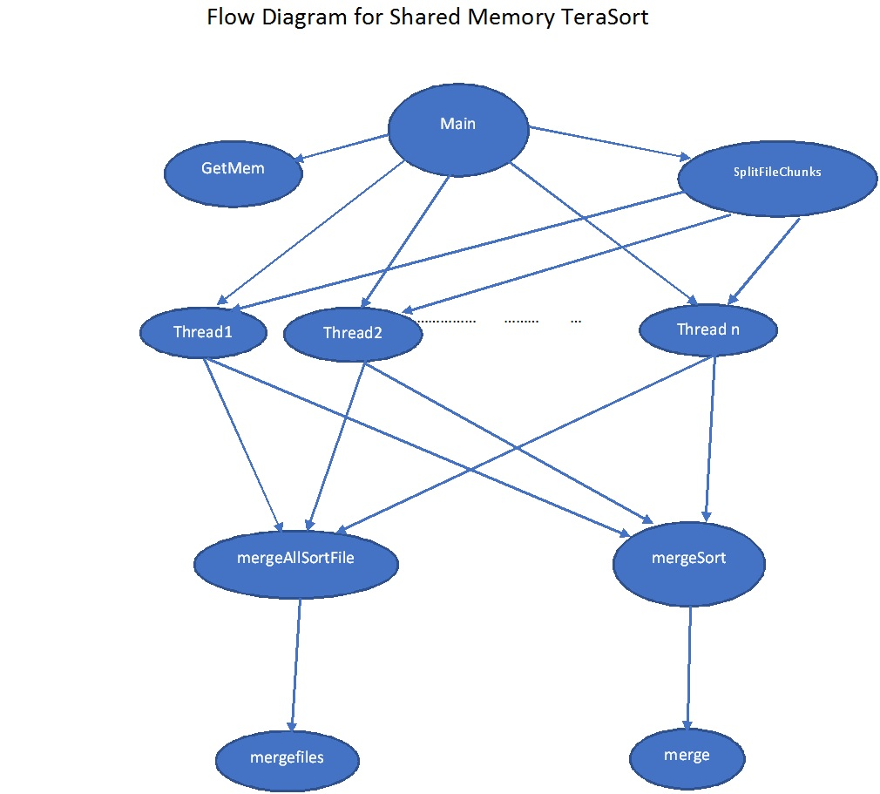

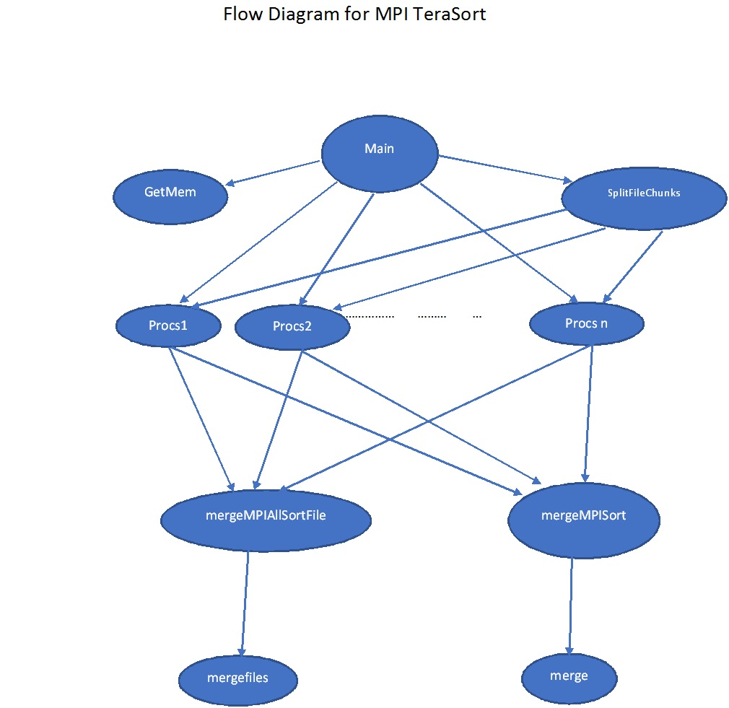

***Performance Evaluation***

***Shared Memory:***

|  |  |  |  |  |
| --- | --- | --- | --- | --- |
| Configuration | 16 | 8 | 4 | 2 |
| 128GB i3.large |  |  |  |  |
| 1TB i3.4x large |  |  |  |  |

***Hadoop and Spark:***

|  |  |  |
| --- | --- | --- |
|  | Hadoop | Spark |
| 128GB i3.large |  |  |
| 1TB i3.4x large |  |  |
| 1TB i3.large (Cluster) |  |  |

***Mpi:***

|  |  |  |  |  |
| --- | --- | --- | --- | --- |
|  |  |  |  |  |
|  |  |  |  |  |
|  |  |  |  |  |
|  |  |  |  |  |

**Configuration 1:-**

**Virtual Cluster (1-node i3.large)**: Setup virtual cluster of 1 node on Amazon EC2 using i3.large instance; generate a dataset of 128GB in size; during performance evaluation, do not include measurement of the time to generate the data, load the data, or verify that the data is sorted correctly; performance evaluation should only include the time to sort the data; after experiments (a), (b), and (c), terminate the instance

**I3.large cpu info:**

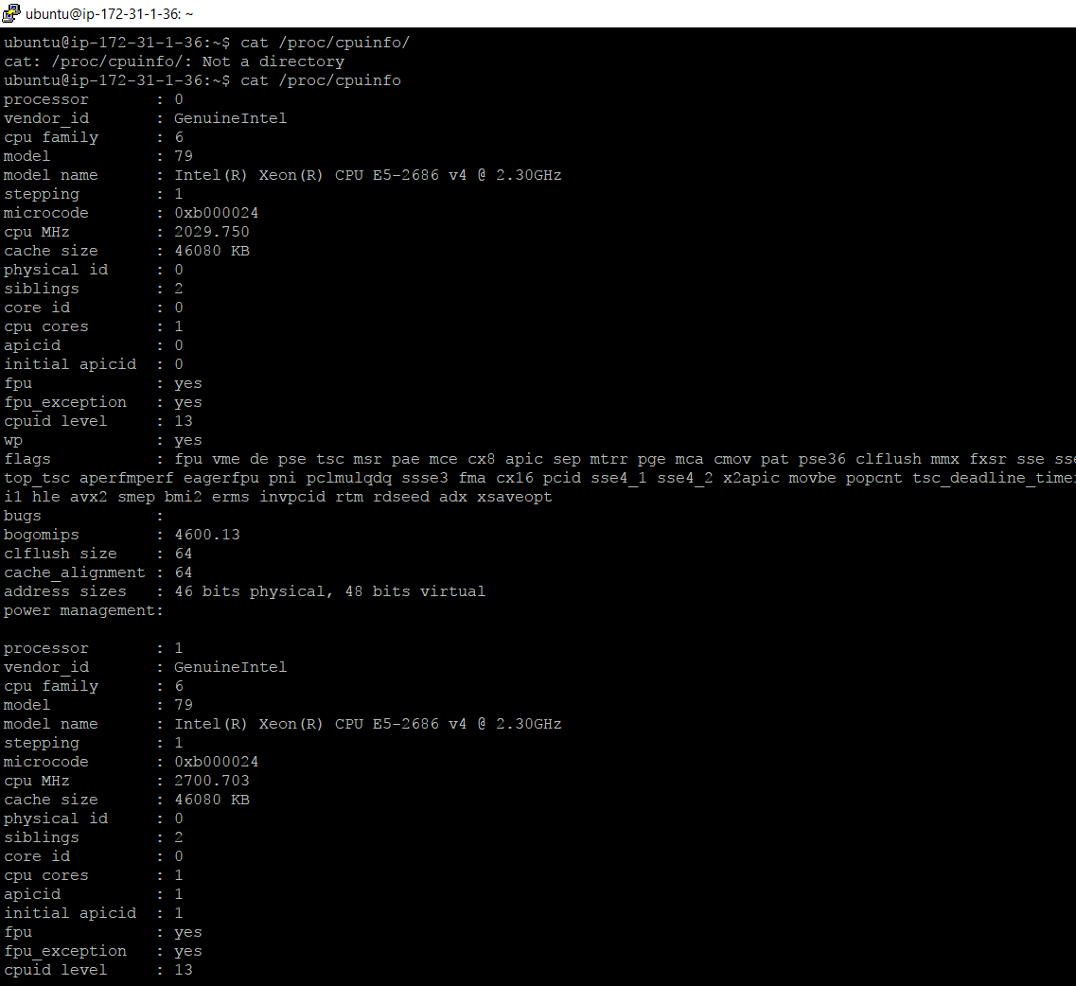

**Input file generation of 128 GB**

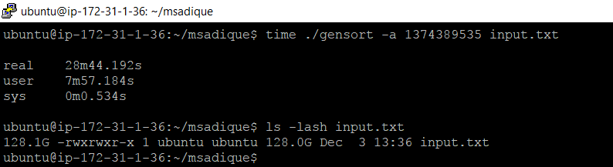

1. **Shared-Memory TeraSort**

Implement the Shared-Memory TeraSort application in your favorite language (without using Hadoop or Spark); generate the 128GB dataset and measure the time to sort it; you should make your Shared-Memory TeraSort multi-threaded to take advantage of multiple cores and SSD storage (which also requires multiple concurrent requests to achieve peak performance)

***1 Thread : Size 128GB***

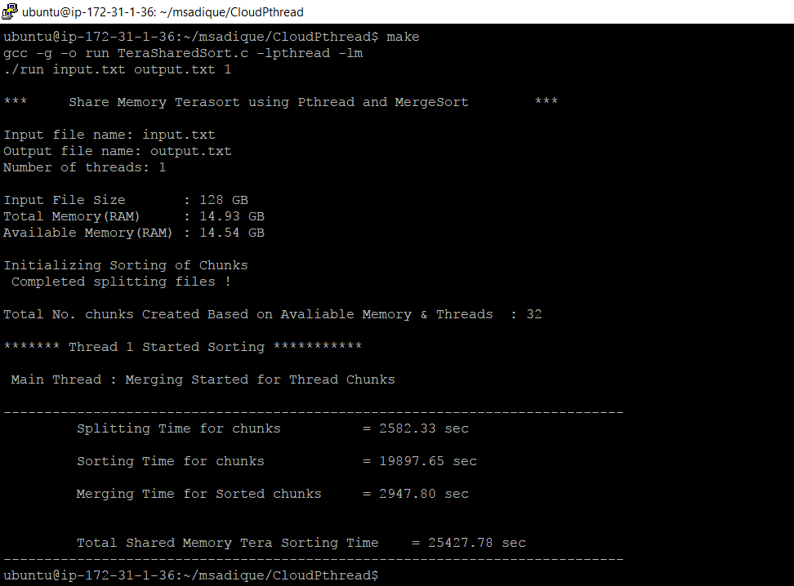

***2 Threads 128GB***

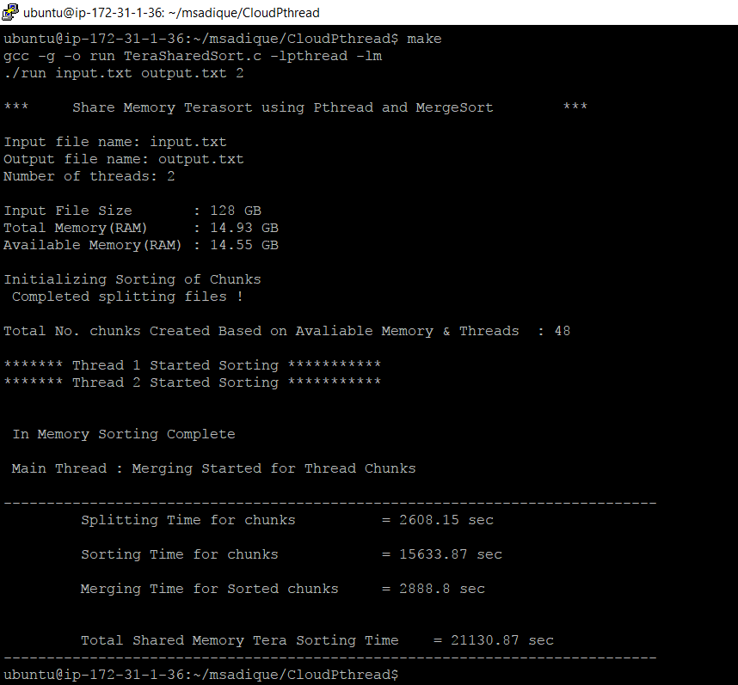

***4 Threads 128GB***

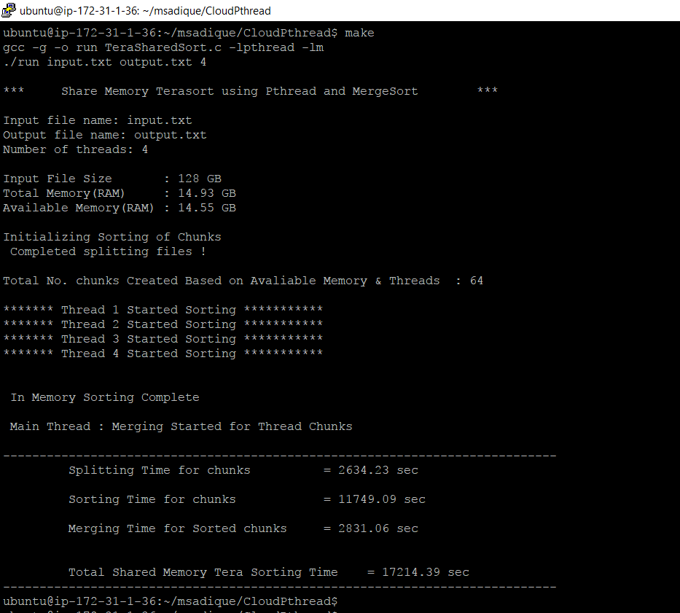

***8 Threads 128GB***

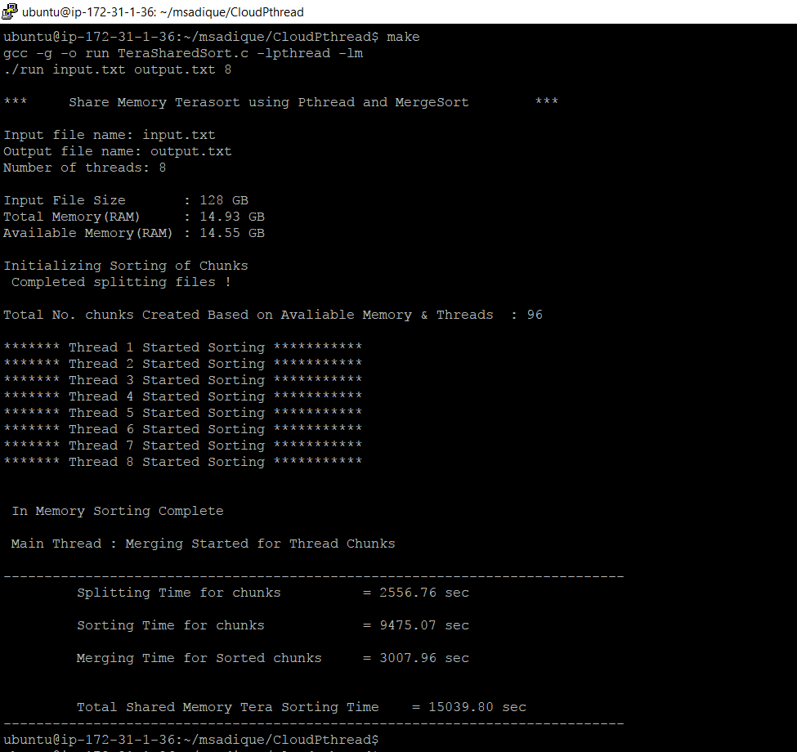

**Table showing Number of threads vs Compute time for above results**

|  |  |
| --- | --- |
| **No. of Threads** | **Computation Time** |
| **1** | **25427.78** |
| **2** | **21130.87** |
| **4** | **17214.39** |
| **8** | **15039.8** |

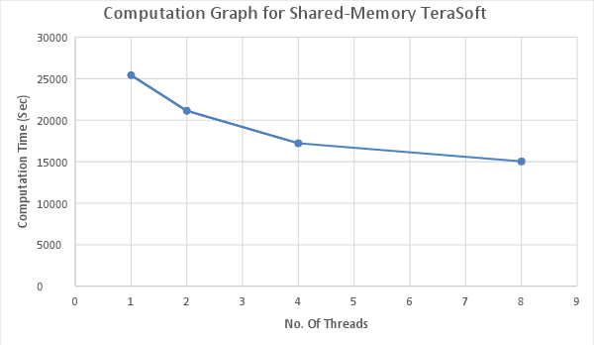

**Results**

**Time taken for running job = *15039.8* secs**

**File size = 128GB**

**Data Read = 128GB**

**Data Write =128GB**

**Total Read & Write = 256GB**

**I/O Throughput = Total Read & Write/(Total Compute Time)**

**=(256*1024)/15039.8**

**=17.43 MB/sec**

**b. Hadoop TeraSort:**

Install Hadoop (including the HDFS distributed file system); turn off replication in order to have lower storage requirement; you must setup your own Hadoop cluster, and cannot use the Amazon Elastic MapReduce (EMR) available from Amazon; all Hadoop components should be configured on this 1 node; load the 128GB dataset into HDFS; implement the Hadoop TeraSort application, and evaluate its performance on 1 node

**Screenshots:**

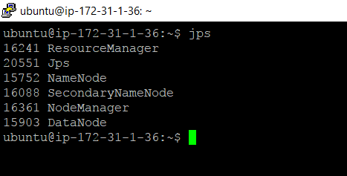

**Time taken to generate Input file**

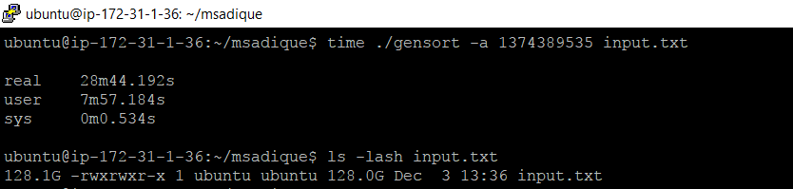

**Time it takes to transfer 128GB file to Hdfs**

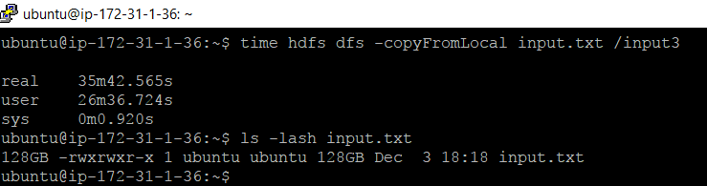

**Hadoop 128GB**

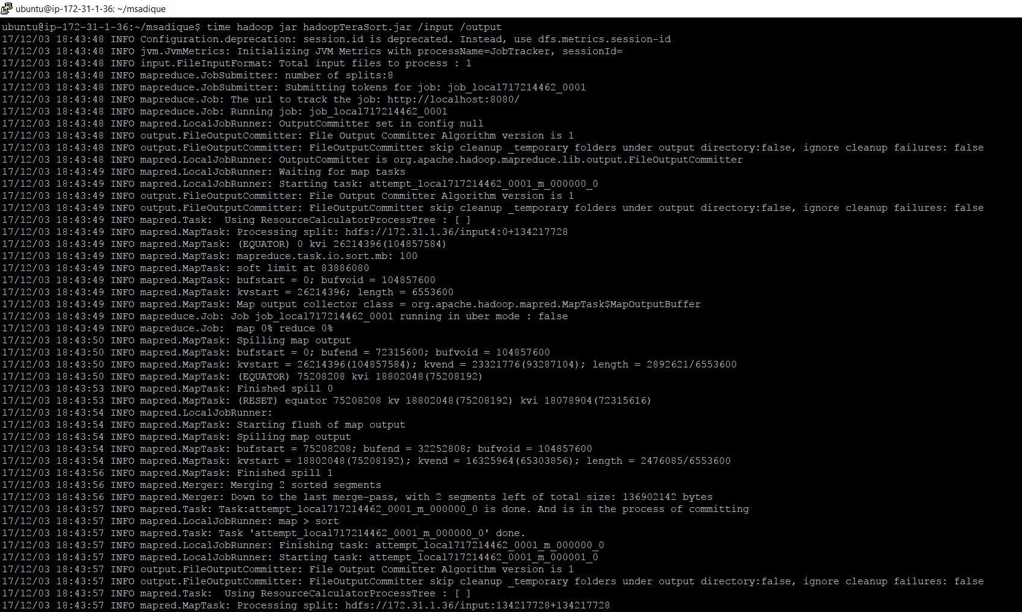

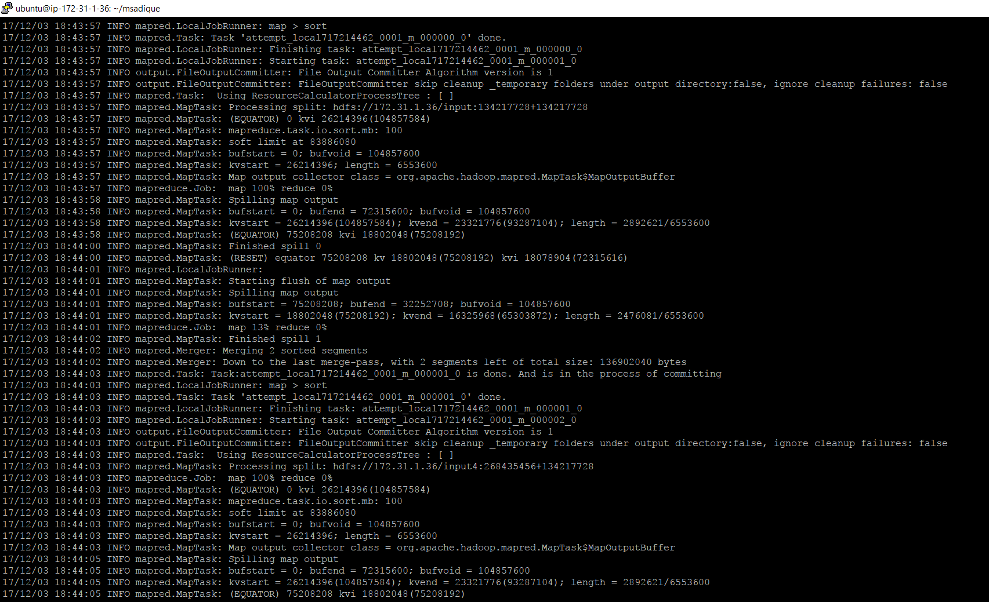

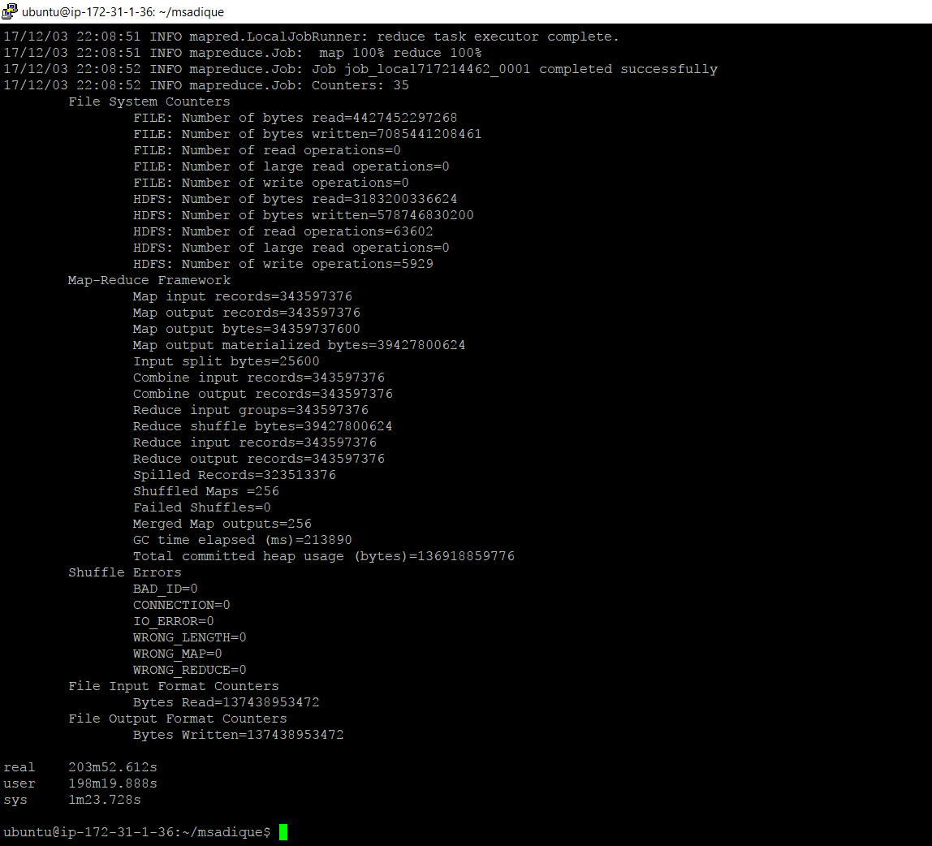

***c. Spark TeraSort:***

Install Spark (including the HDFS distributed file system); you must setup your own Spark cluster, and cannot use EMR to launch the Spark cluster; load the 128GB dataset into HDFS (unless its already loaded); implement the Spark TeraSort application, and evaluate its performance on 1 node.

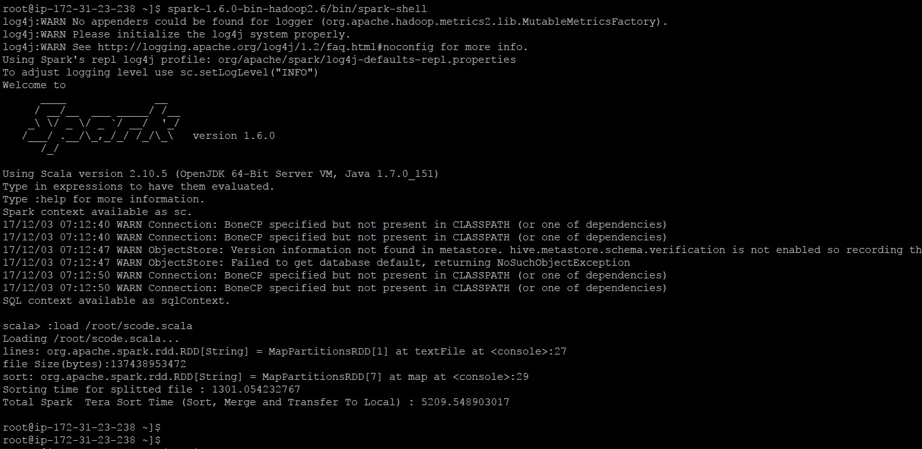

**d. MPI TeraSort:**

Implement and evaluate external sort with MPI; generate the 128GB dataset and measure the time to sort it; you should make your MPI TeraSort uses multiple processes (ranks) to take advantage of multiple cores and SSD storage (which also requires multiple concurrent requests to achieve peak performance)

**Installing MPI on I3.large**

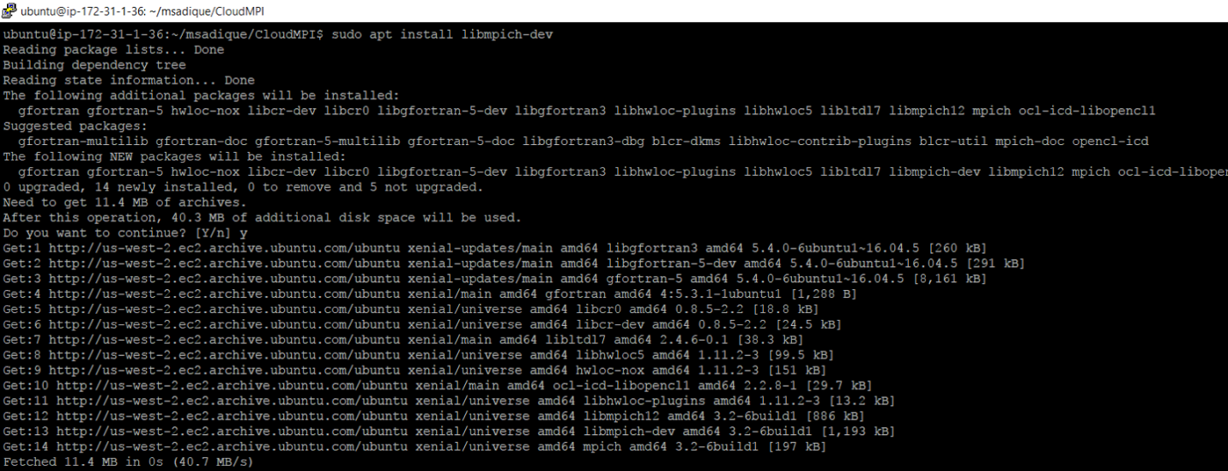

***Number of  Processing Node = 1***

***File Size :128GB***

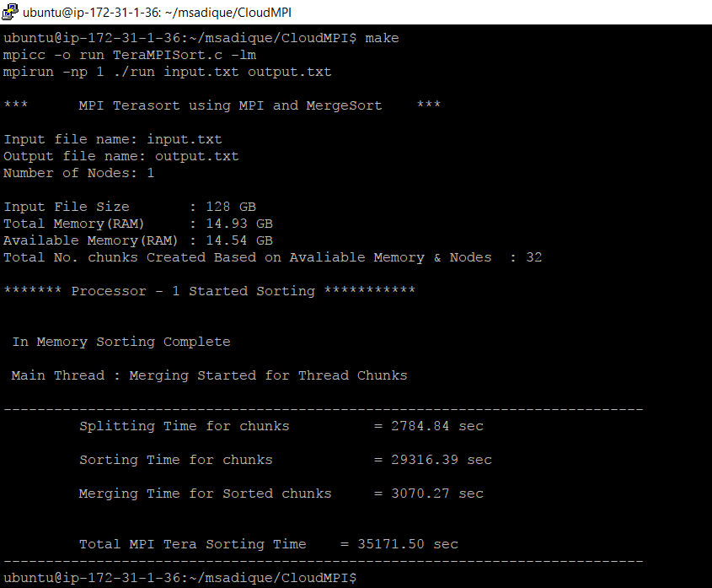

***Number of  Processing Node = 2***

***File Size :128GB***

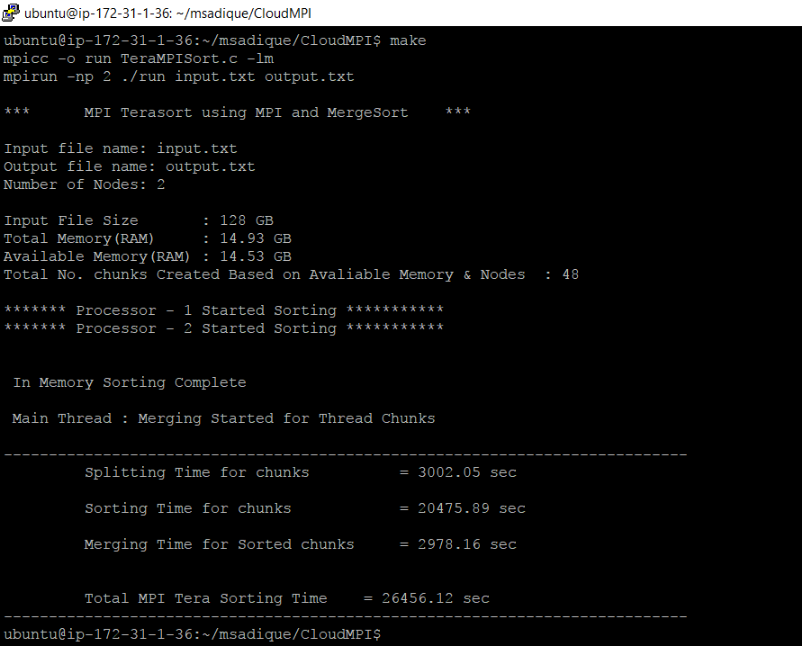

***Number of  Processing Node = 4***

***File Size :128GB***

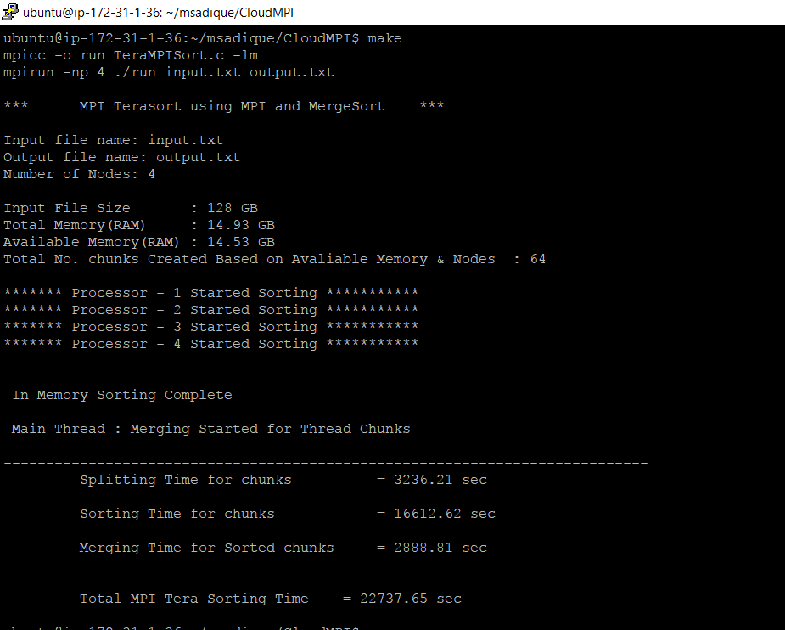

***Number of  Processing Node = 8***

***File Size :128GB***

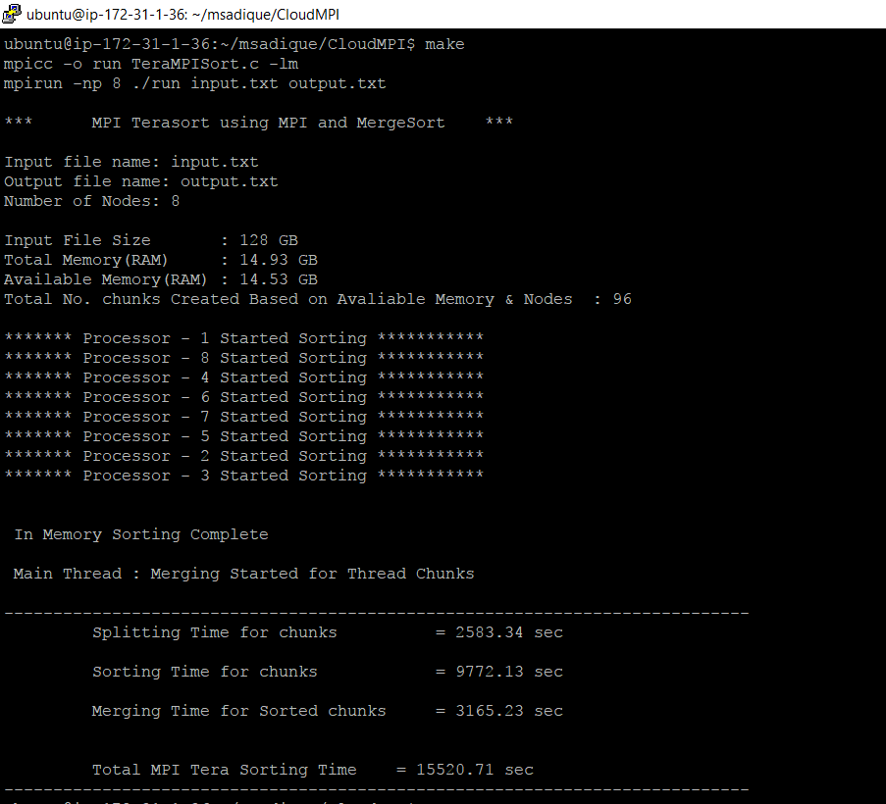

**Results**

**Time taken for running job = *15520.7* secs**

**File size = 128GB**

**Data Read = 128GB**

**Data Write =128GB**

**Total Read & Write = 256GB**

**I/O Throughput = Total Read & Write/(Total Compute Time)**

**=256*1024/15520.7**

**=16.89 MB/sec**

**Below table shows Number of Threads vs Compute Time**

|  |  |
| --- | --- |
| **No. Threads** | **Computation Time** |
| **1** | **35171.504** |
| **2** | **26456.122** |
| **4** | **22737.66** |
| **8** | **15520.71** |

***Configuration 2***

***Virtual Cluster (1-node i3.4xlarge):-***

*Setup virtual cluster of 1 node on Amazon EC2 using i3.4xlarge instance; generate a dataset of 1TB in size; during performance evaluation, do not include measurement of the time to generate the data, load the data, or verify that the data is sorted correctly; performance evaluation should only include the time to sort the data; after experiments (a), (b), and (c), terminate the instance*

***a. Shared-Memory TeraSort:***

Evaluate Shared-Memory TeraSort application and measure the time to sort the 1TB dataset on 1 node (don’t forget to increase the number of threads to make use of the 16-core instance)

**Screenshots: 1 Thread : 1TB**

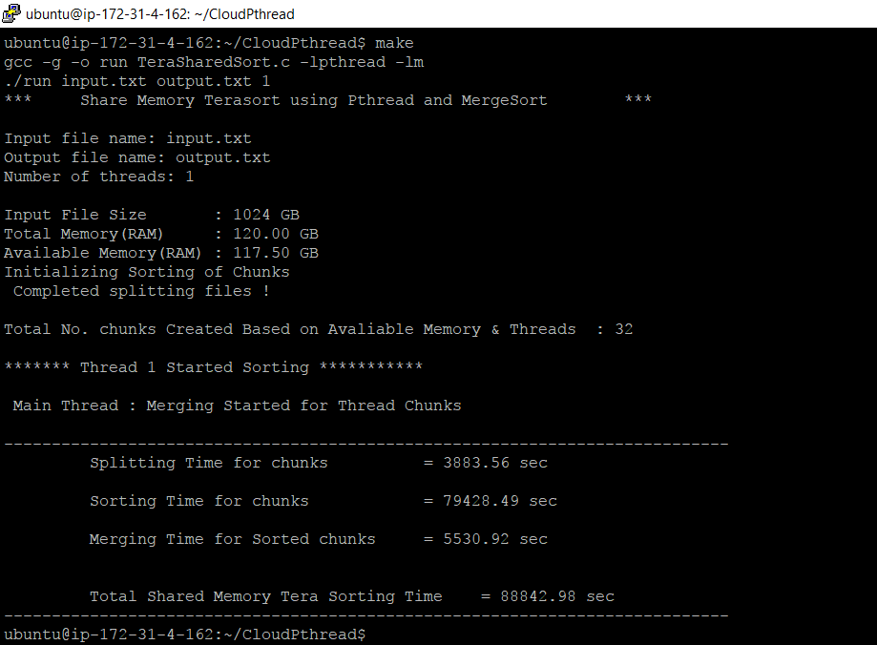

**No of threads : 2 File size:1024 GB**

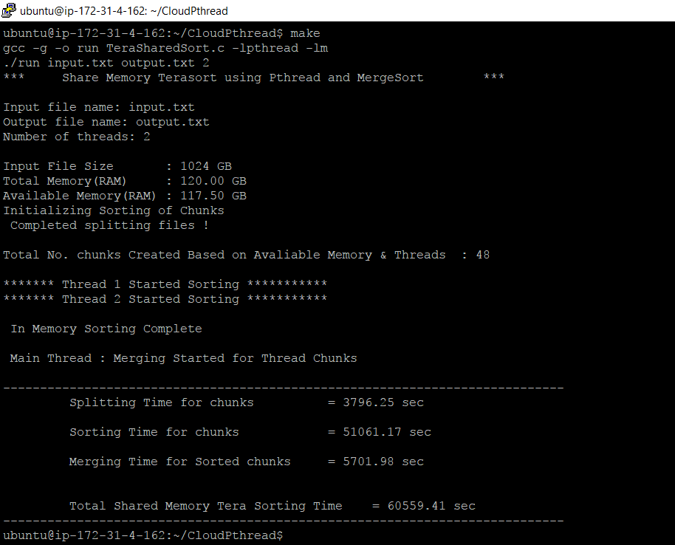

**No of threads : 4**

**File size:1024 GB**

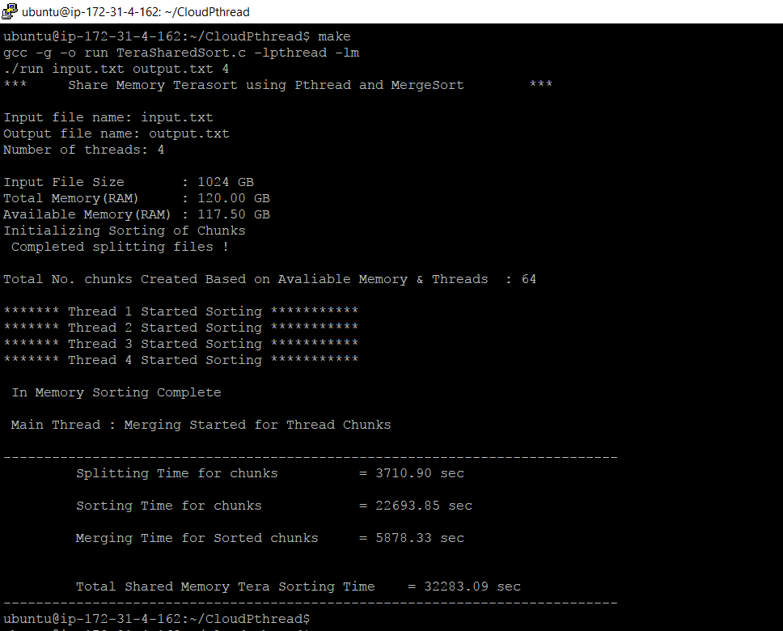

**No of threads : 8**

**File size:1024 GB**

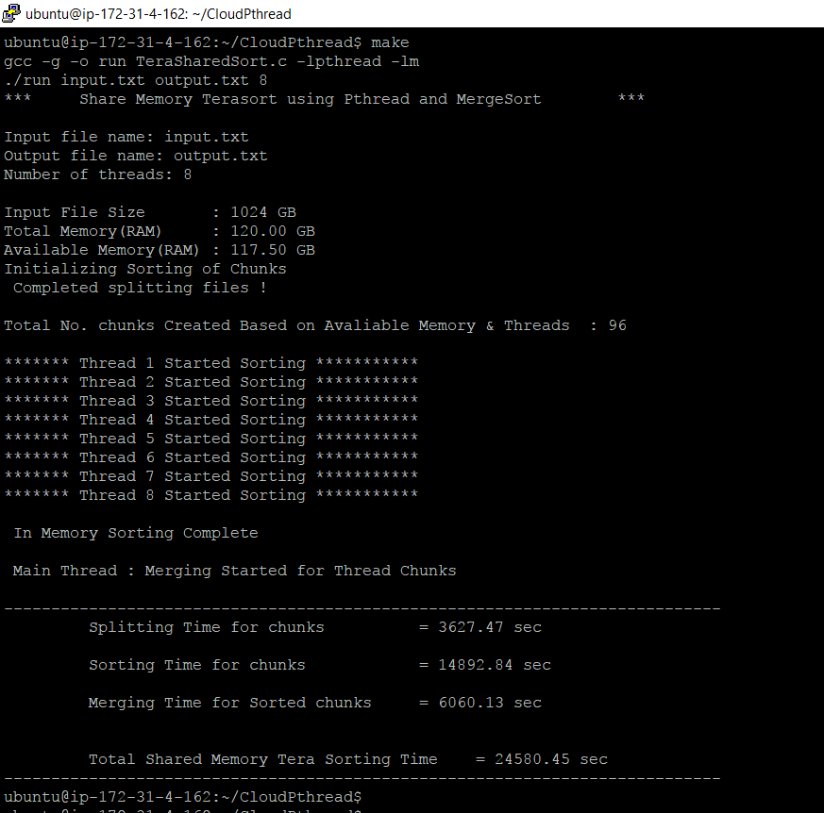

**No of Threads : 16**

**File Size: 1024 GB**

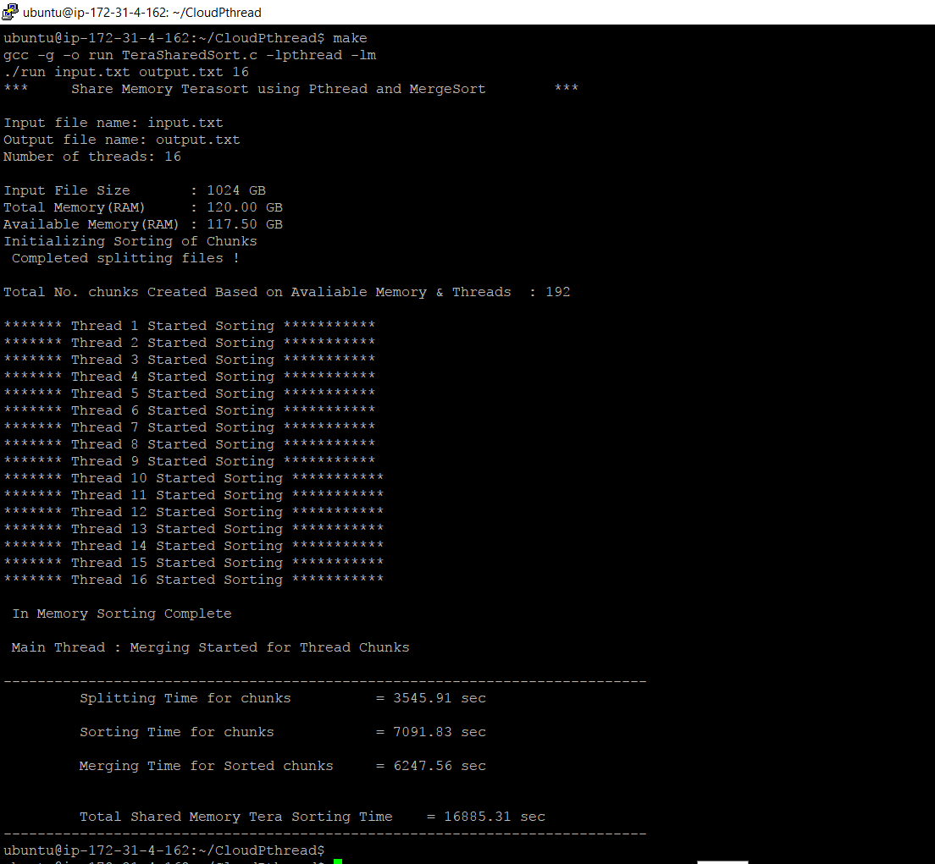

**Below table shows Number of Threads vs compute time**

|  |  |
| --- | --- |
| **No. Threads** | **Computation Time** |
| **1** | **88842.98** |
| **2** | **60559.41** |
| **4** | **32283.09** |
| **8** | **24580.45** |
| **16** | **16885.31** |

***b. Hadoop TeraSort:***

Configure HDFS with no replication; evaluate Hadoop TeraSort application and measure the time to sort the 1TB dataset on 1 node (don’t forget to increase the number of mappers and reducers to make use of the 16-core instance)

**File 1TB generation Time**

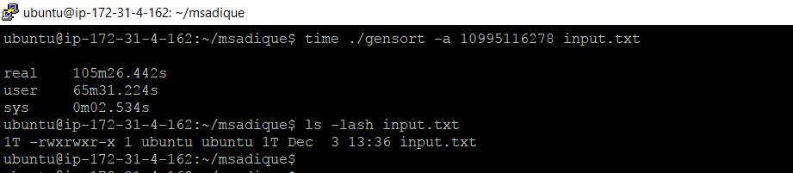

**1 TB File Transfer To HDFS**

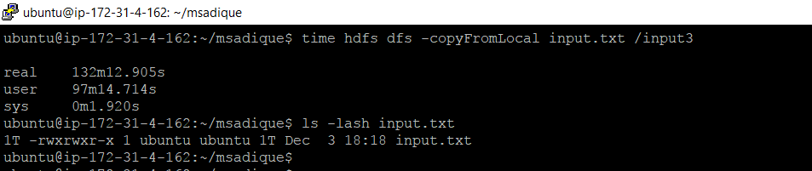

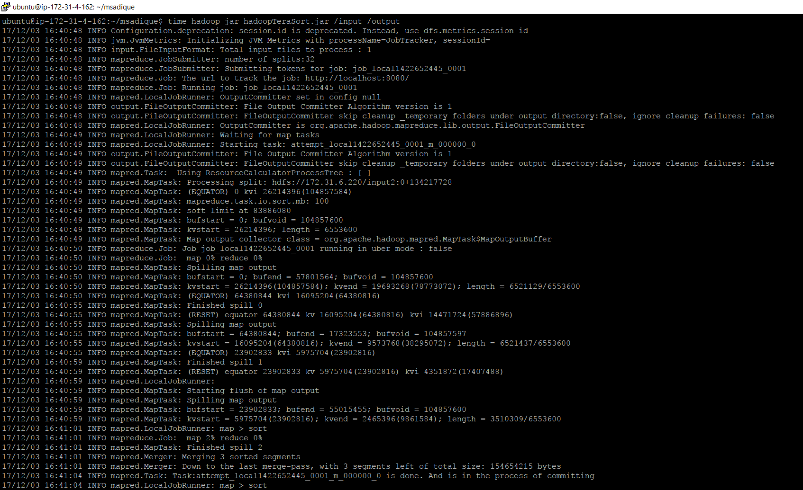

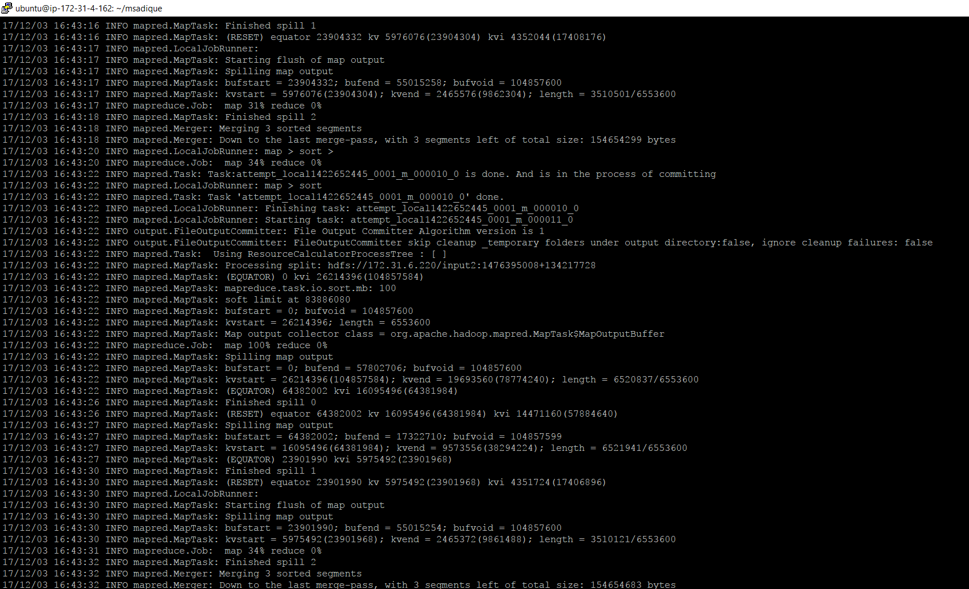

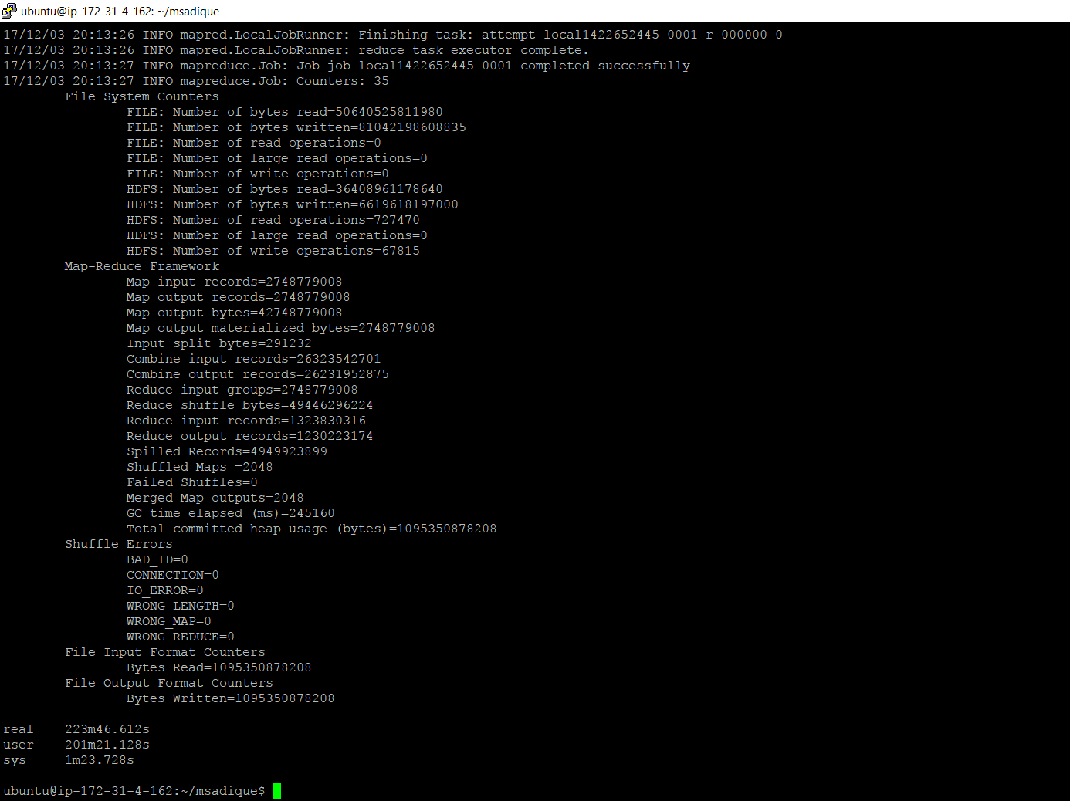

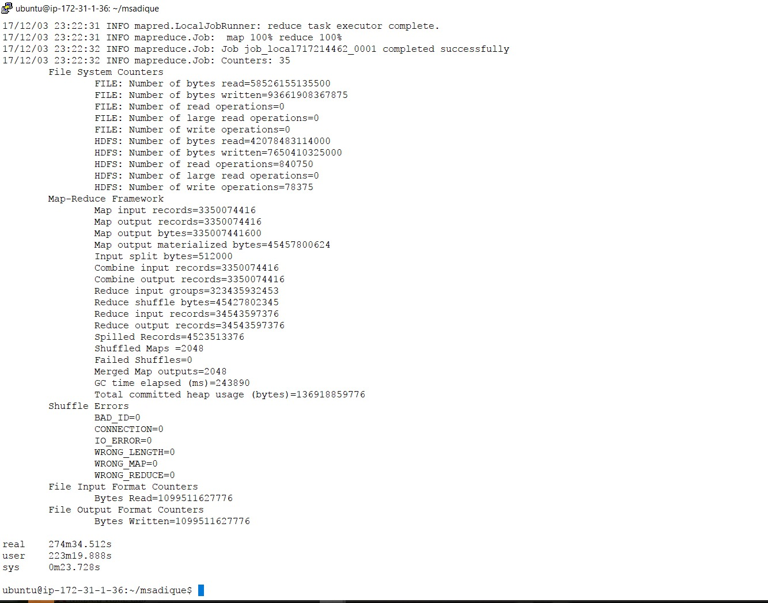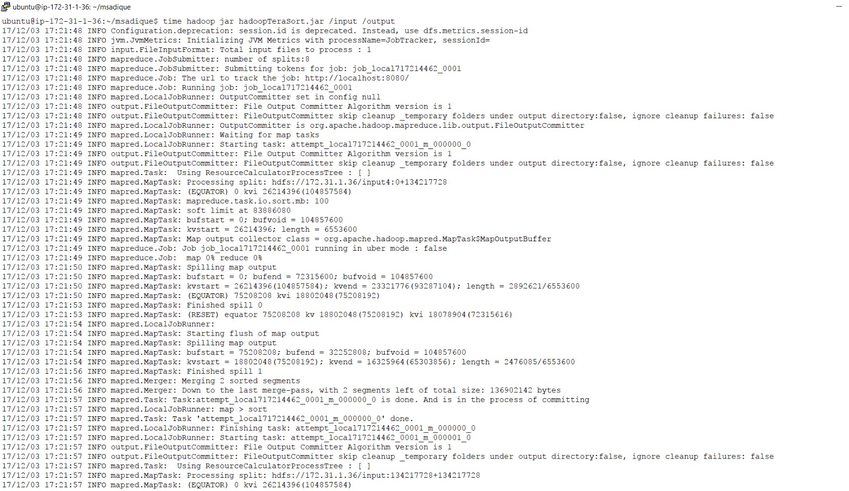

***c. Spark TeraSort:***

Configure HDFS with no replication; evaluate Spark TeraSort application and measure the time to sort the 1TB dataset on 1 node (don’t forget to increase the parallelism to make use of the 16-core instance)

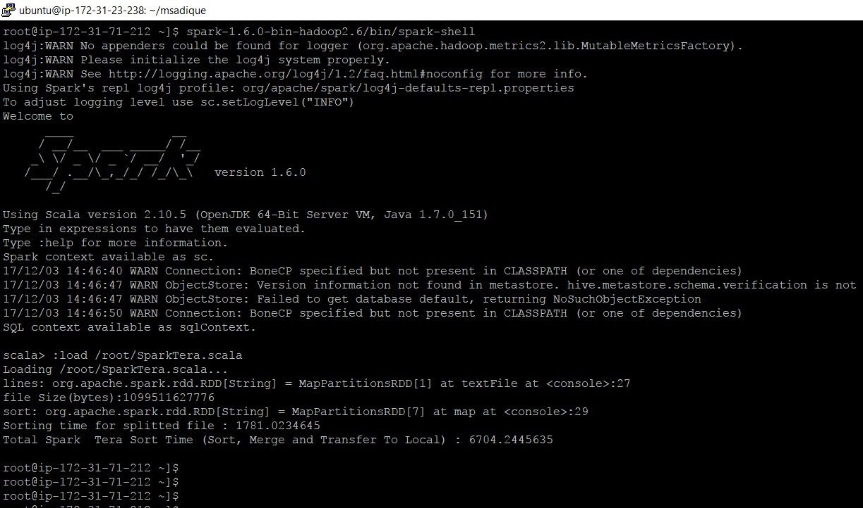

**d. MPI TeraSort:**

Evaluate MPI TeraSort application and measure the time to sort the 1TB dataset on 1 node (don’t forget to increase the number of processes to make use of the 16-core instance)

**No of Nodes :1**

**Files Size: 1024 Gb**

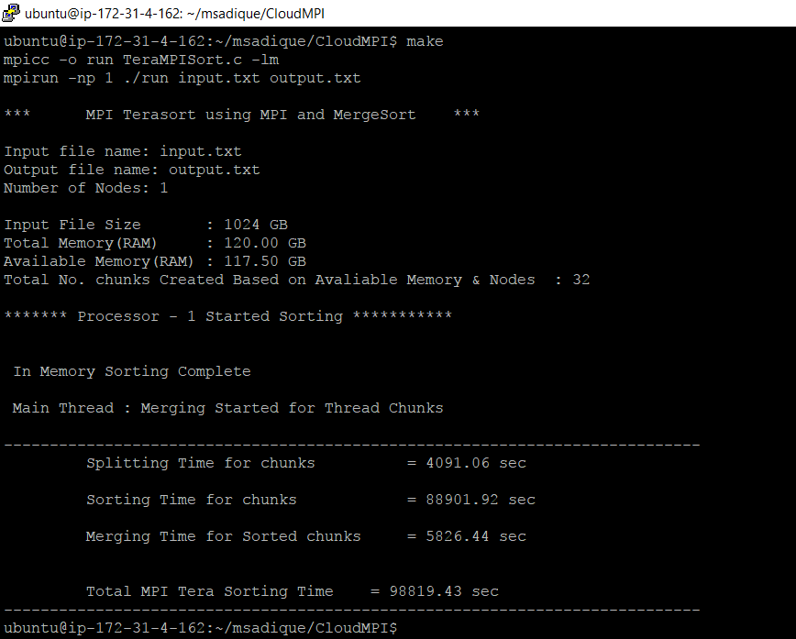

**No of Nodes:2**

**File Size: 1024 GB**

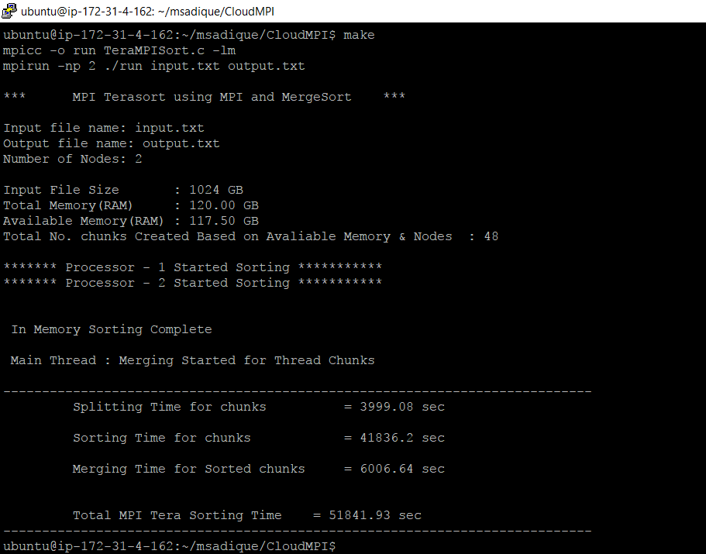

**No of Nodes:4**

**File Size: 1024 GB**

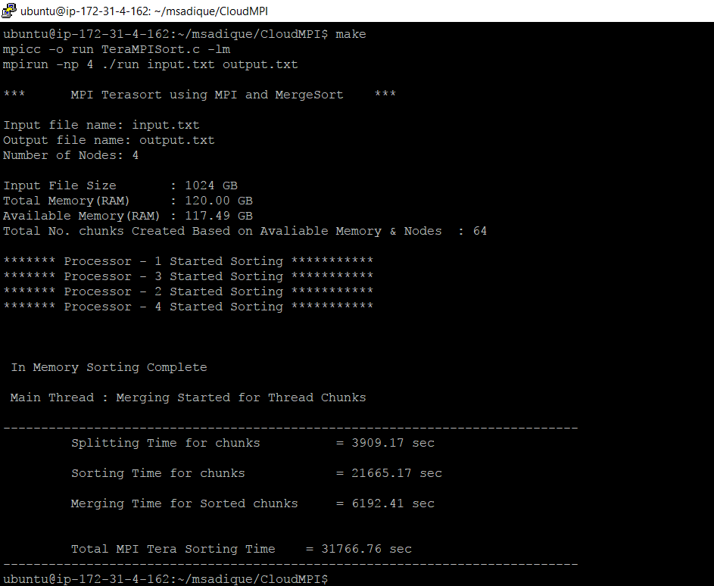

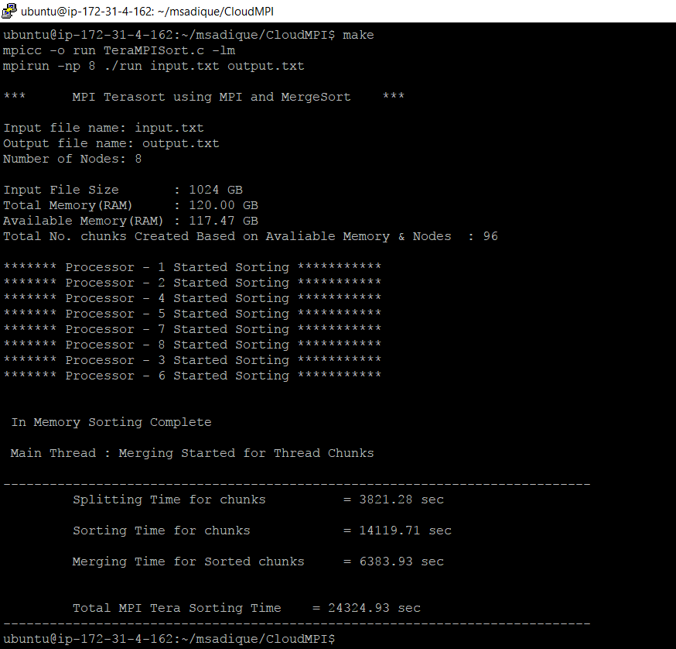

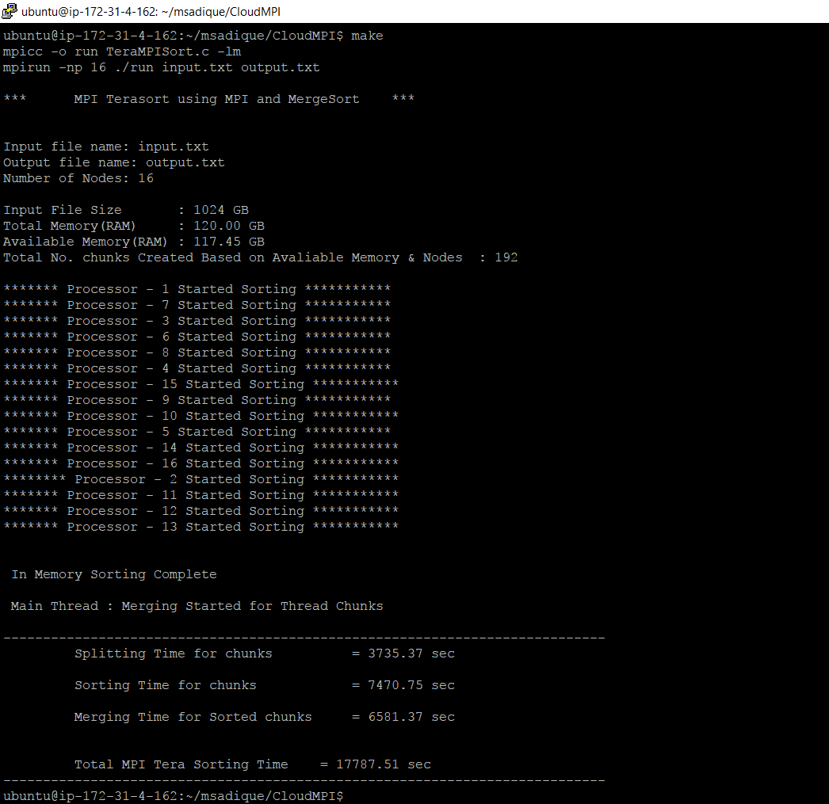

|  |  |
| --- | --- |
| **No. Threads** | **Computation Time** |
| **1** | **98819.43** |
| **2** | **51841.93** |
| **4** | **31766.76** |
| **8** | **24324.94** |
| **16** | **17787.5** |

***Configuration 3***

***Virtual Cluster (8-nodes i3.large):***

*Setup virtual cluster of 8 nodes on Amazon EC2 using i3.large instance types; generate a dataset of 1TB in size; during performance evaluation, do not include measurement of the time to generate the data, load the data, or verify that the data is sorted correctly; performance evaluation should only include the time to sort the data; after experiments (a) and (b), terminate the instance*

***a. Hadoop TeraSort:***

Configure Hadoop to span all 8 nodes, and HDFS with no replication; evaluate Hadoop TeraSort application and measure the time to sort the 1TB dataset

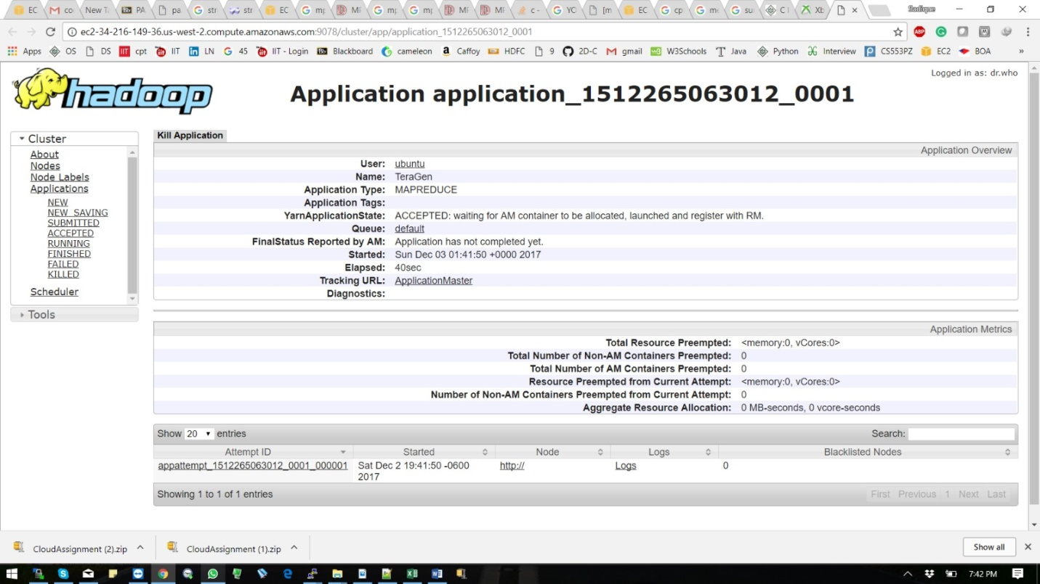

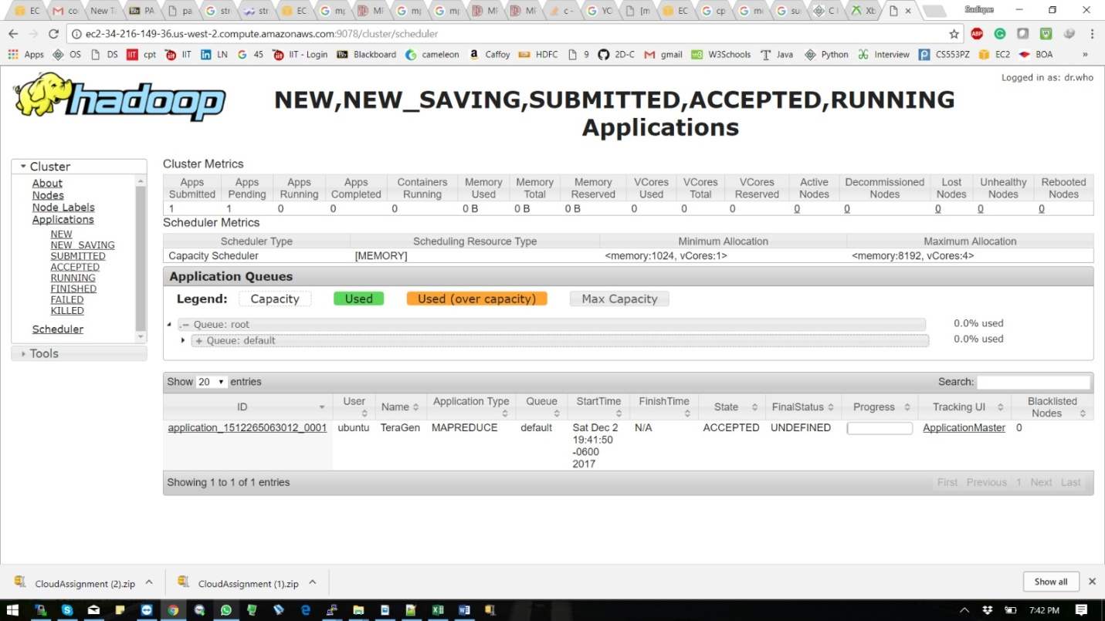

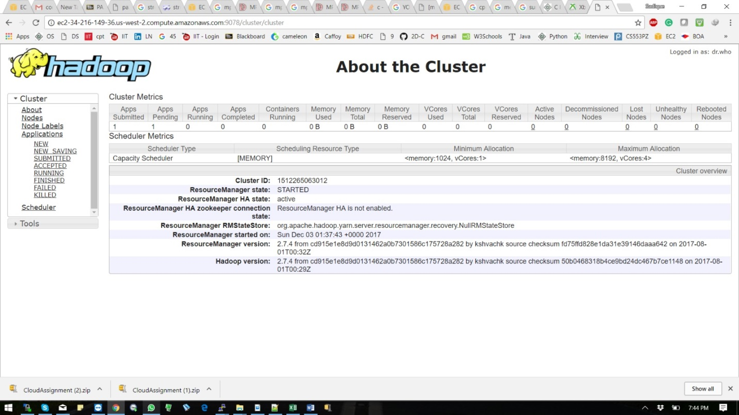

***b. Spark TeraSort:***

*Configure Spark and HDFS to span all 8 nodes, and HDFS with no replication; make sure to disable replication for RDD as well; evaluate Spark TeraSort application and measure the time to sort the 1TB dataset*

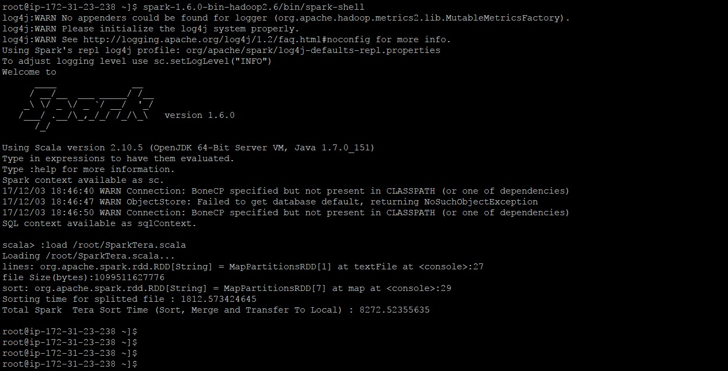

***c. MPI TeraSort:***

Configure MPI to span all 8 nodes; configure a shared/parallel/distributed file system (e.g. NFS, Lustre, OrangeFS, Gluster, Ceph) without replication; evaluate MPI TeraSort application and measure the time to sort the 1TB dataset on 8 nodes; you could probably configure MPI to work without a shared file system, but the implementation of your application might be more complex; note that NFS will likely give the worst performance due to the poor scalability of data access performance, so you are encouraged to use a more sophisticated distributed/parallel file system instead

**1 Thread 1TB**

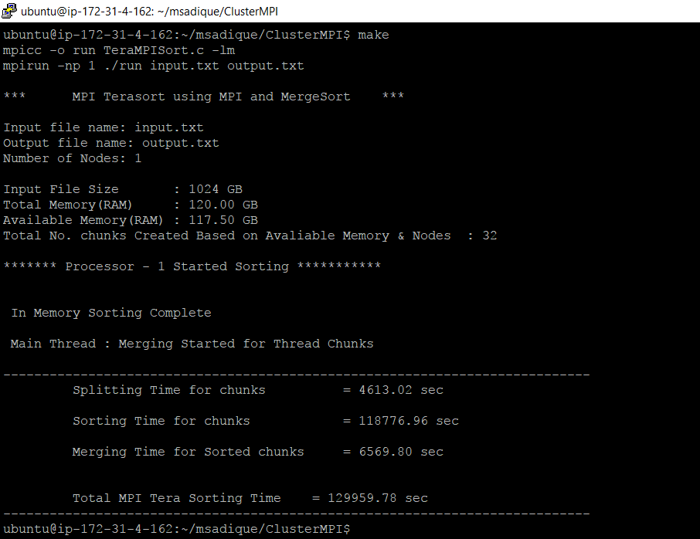

**2 Thread 1TB**

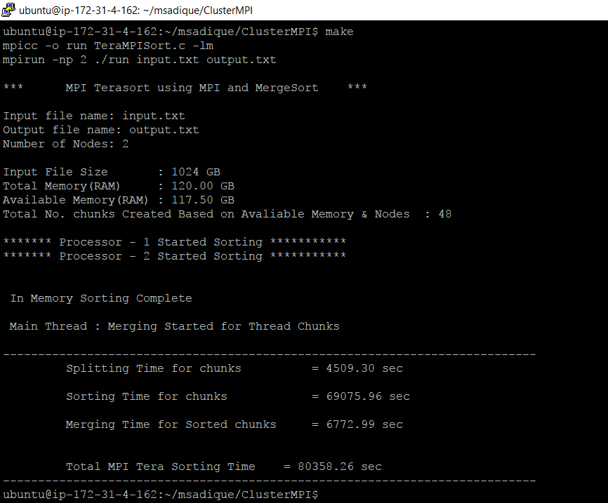

**4 Thread 1TB**

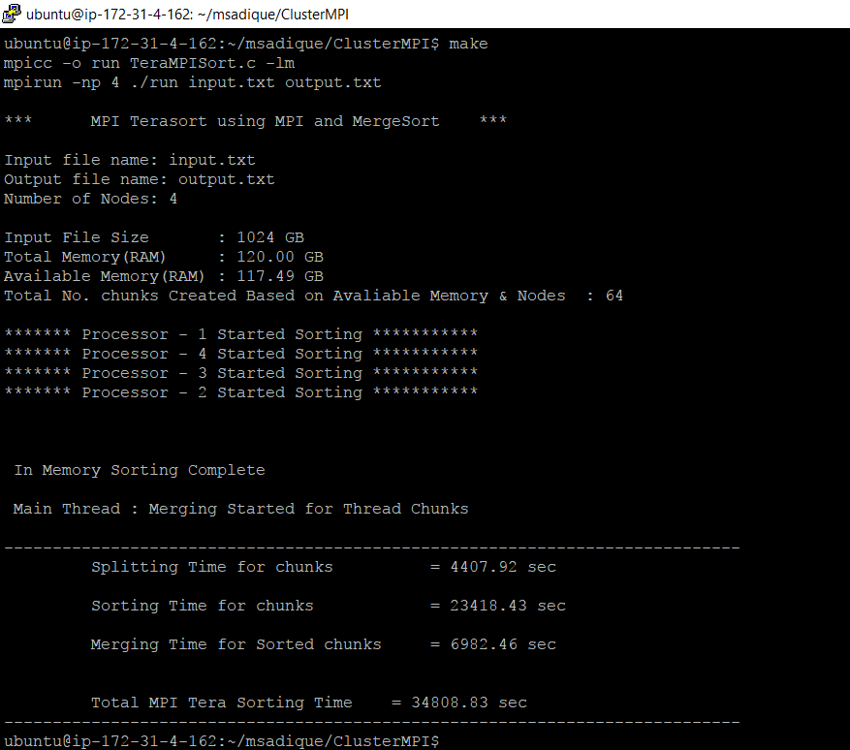

**8 Thread 1 TB**

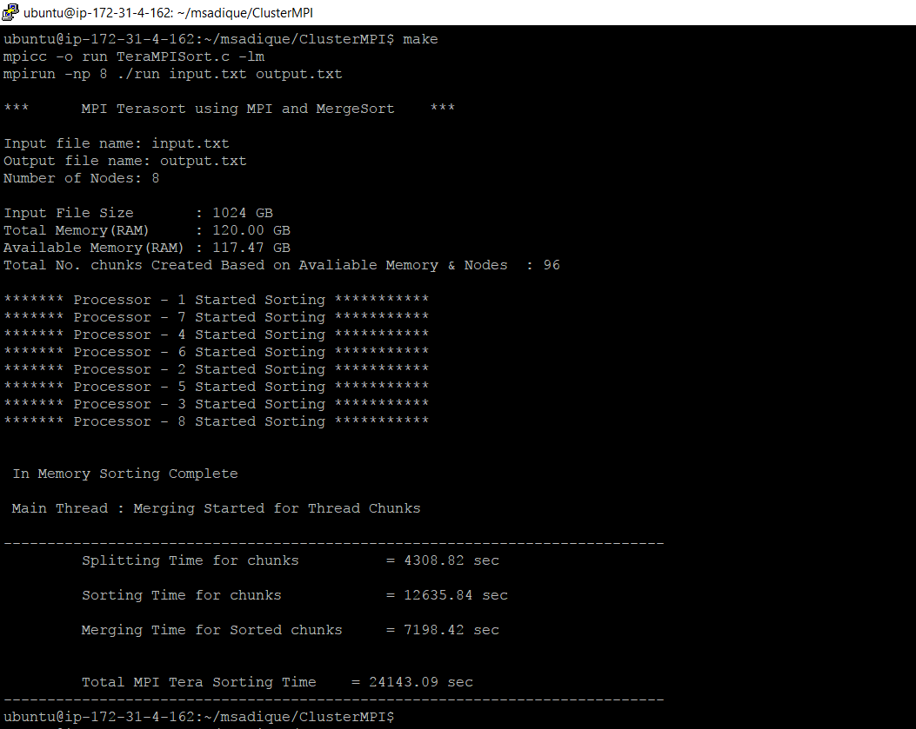

**16 Thread 1 TB**

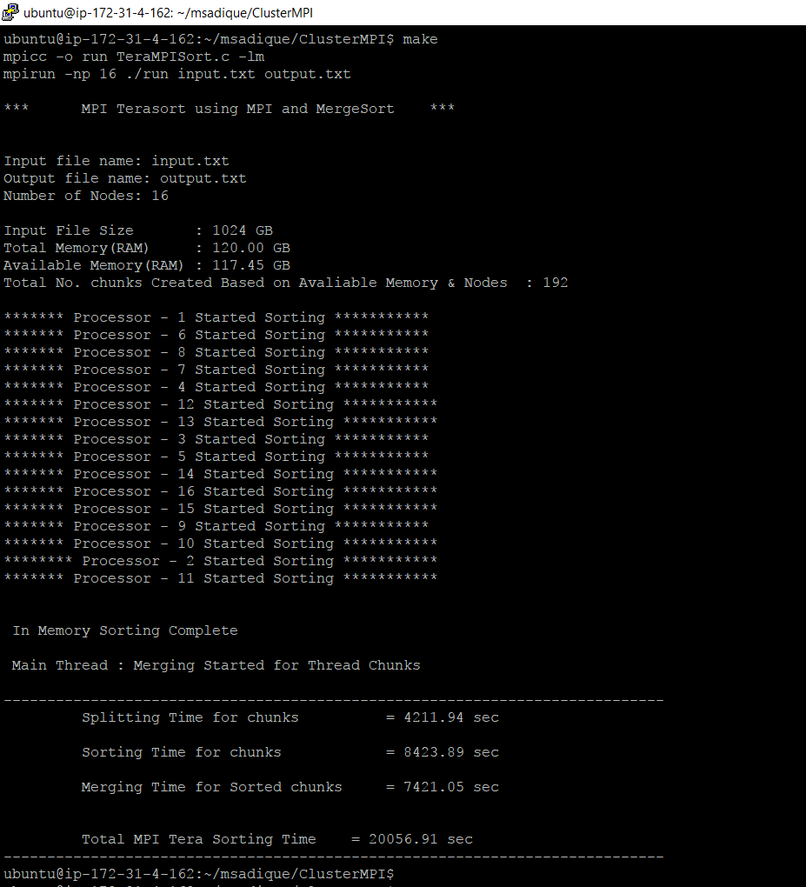

|  |  |
| --- | --- |
| **No. of Threads** | **Computation Time** |
| **1** | **129959.78** |
| **2** | **80358.26** |
| **4** | **34808.83** |
| **8** | **24143.09** |
| **16** | **20056.9** |

***Performance Evaluation Table***

|  |  |  |  |  |
| --- | --- | --- | --- | --- |
| **Experiment (instance/dataset)** | **Shared Memory TeraSort** | **Hadoop TeraSort** | **Spark TeraSort** | **MPI TeraSort** |
| **Compute Time (sec) [1xi3.large 128GB]** | ***15039.8*** | ***12232.6*** | ***5209.54*** | ***15520.7*** |
| **Data Read (GB) [1xi3.large 128GB]** | ***128*** | ***128*** | ***128*** | ***128*** |
| **Data Write (GB) [1xi3.large 128GB]** | ***128*** | ***128*** | ***128*** | ***128*** |
| **I/O Throughput (MB/sec) [1xi3.large 128GB]** | ***17.43*** | ***21.43*** | ***50.32*** | ***16.89*** |
| **Compute Time (sec) [1xi3.4xlarge 1TB]** | ***16885.3*** | ***13426.1*** | ***6704.24*** | ***17787.5*** |
| **Data Read (GB) [1xi3.4xlarge 1TB]** | ***1024*** | ***1024*** | ***1024*** | ***1024*** |
| **Data Write (GB) [1xi3.4xlarge 1TB]** | ***1024*** | ***1024*** | ***1024*** | ***1024*** |
| **I/O Throughput (MB/sec) [1xi3.4xlarge 1TB]** | ***124.2*** | ***156.2*** | ***312.81*** | ***117.9*** |
| **Compute Time (sec) [8xi3.large 1TB]** | N/A | ***16440.5*** | ***8272.59*** | ***20056.9*** |
| **Data Read (GB) [8xi3.large 1TB]** | N/A | ***1024*** | ***1024*** | ***1024*** |
| **Data Write (GB) [8xi3.large 1TB]** | N/A | ***1024*** | ***1024*** | ***1024*** |
| **I/O Throughput (MB/sec) [8xi3.large 1TB]** | N/A | ***127.56*** | ***253.4*** | ***104.56*** |
| **Speedup (weak scale)** | ***7.125*** | ***5.952*** | ***5.035*** | ***6.19*** |
| **Efficiency (weak scale)** | ***89.07%*** | ***74.4%*** | ***62.94%*** | ***77.38%*** |

|  |  |  |  |
| --- | --- | --- | --- |
|  | **3.large (128 GB)** | **i3.4xlarge (1TB)** | **i3.large 1TB (Cluster)** |
| **Shared Memory TeraSort** | ***15039.8*** | ***16885.3*** | N/A |
| **MPI Tera Sort** | ***15520.7*** | ***17787.5*** | ***20056.9*** |
| **Hadoop Tera Sort** | ***12232.6*** | ***13426.1*** | ***16440.5*** |
| **Spark Tera Sort** | ***5209.54*** | ***6704.24*** | ***8272.59*** |

|  |  |  |  |
| --- | --- | --- | --- |
|  | **i3.large (128 GB)** | **i3.4xlarge (1TB)** | **i3.large 1TB (Cluster)** |
| **Shared Memory TeraSort** | ***17.43*** | ***124.2*** |  |
| **MPI Tera Sort** | ***16.89*** | ***117.9*** | ***104.56*** |
| **Hadoop Tera Sort** | ***21.43*** | ***156.2*** | ***127.56*** |
| **Spark Tera Sort** | ***50.32*** | ***312.81*** | ***253.4*** |

***Speedup (week Scale)***

|  |  |
| --- | --- |
|  | **Speedup(week Scale)** |
| **Shared Memory TeraSort** | ***7.125*** |
| **MPI Tera Sort** | ***6.19*** |
| **Hadoop Tera Sort** | ***5.952*** |
| **Spark Tera Sort** | ***5.035*** |

***Speedup is measure i3.large single instance and i3.large cluster (8 instance) between Hadoop tera sort , MPI TeraSort and Spark Tera Sort except Shared Memory TeraSort which is measure between i3.large and i3.4xlarge.***

***Spark have low speedup because communication time is higher as compare to other configuration that’s why its speeds is low***

|  |  |
| --- | --- |
|  | **Efficiency (weak scale)** |
| **Shared Memory TeraSort** | ***89.07%*** |
| **MPI Tera Sort** | ***77.38%*** |
| **Hadoop Tera Sort** | ***74.40%*** |
| **Spark Tera Sort** | ***62.94%*** |

***Spark have low Efficiency because communication time is higher as compare to other configuration that’s why its efficiency is low***

***Conclusion :***

We performed experiments on i3.large and i3.4xlarge instances and observed the reading, throughput speed and efficiency.Based on these we conclude that:

* Shared Memory TeraSort Speedup of i3.4xlarge is almost 8 times faster as compare i3.large.
* MPI Tera Sort based on number of processor in instances of i3.large have which have 2vcpu so maximum performance for i3.large is goes to 2nodes
* i3.4xlarge have 16vcpu so maximum efficiency and performance is achieved for 16 pthread for Shared memory and 16np for MPI Tera sort.
* Apache Spark is lightning fast big data framework that enhance the computational speed. Hadoop MapReduce, performs read and write from the disk as a result it slows down the computation.
* Spark can run on top of Hadoop so it provides a better computational speed result.
* It is easy to program Spark because of high-level operators with RDD – Resilient Distributed Dataset.
* In Hadoop, each and every operation needs to be handcoded which makes it very difficult to work.
* But Spark provides low-latency computing.
* Hadoop provides high latency computing framework.
* One advantage that we noticed is that Spark can process data interactively.
* And MapReduce doesn’t have an interactive mode.
* Spark is fault-tolerant. So In case of any failure we are not required there is to restart the application from scratch and also this applies to Hadoop mapreduce.
* We noticed that Spark is less secure when compared to MapReduce because authenticate through shared secret password authentication process.
* Apache Hadoop MapReduce is more secure because it supports Kerberos and it also supports Access Control Lists (ACLs) which are a traditional file permission model.
* Spark requires a lot of RAM to run in-memory so overall it is costly.
* MapReduce is a cheaper in comparison to Spark.
* Scala is used to develop spark.
* Hadoop Mapreduce is developed in java.

***References:***

* [*https://aws.amazon.com/*](https://aws.amazon.com/)
* [*https://www.ec2instances.info/*](https://www.ec2instances.info/)
* [*http://hadoop.apache.org/*](http://hadoop.apache.org/)
* [*https://spark.apache.org/downloads.html*](https://spark.apache.org/downloads.html)
* http://ant.apache.org/bindownload.cgi
* https://letsdobigdata.wordpress.com/2014/01/13/setting-up-hadoop-1-2-1-multi-node-cluster-on-amazon-ec2-part-2/
* [*http://www.ordinal.com/gensort.html*](http://www.ordinal.com/gensort.html)
* [*https://www.edureka.co/blog/setting-up-a-multi-node-cluster-in-hadoop-2.X*](https://www.edureka.co/blog/setting-up-a-multi-node-cluster-in-hadoop-2.X)
* <https://letsdobigdata.wordpress.com/2014/01/13/setting-up-hadoop-multi-node-cluster-on-amazon-ec2>
* http://spark.apache.org/downloads.html
* http://spark.apache.org/docs/latest/cluster-overview.html